Shelf Logic® Quik Plan
Version 1.0 Release .00
User’s Manual

July 7, 2004

©2004 Shelf Logic Software
Shelf Logic® is a registered trademark of Shelf Logic Software

Table of Contents

Section 1 – Introduction 6
Welcome to Shelf Logic® Quik Plan 6
Getting Help 6
About This User Manual 6
Online Help 7
Training 7
Technical Support 8
What Does Technical Support Cover? 8
Image Support 9
Shelf Logic® Web Site User Section 9
System Requirements 9
Section 2 – Installation 10
Installing Shelf Logic® Quik Plan 10
Instructions for First Time Installations 10
Registering Shelf Logic® Quik Plan 11
Upgrading From a Previous Version 12
Moving Shelf Logic® Quik Plan 12
Reinstalling Shelf Logic® Quik Plan 12
Getting Started 13
Starting Shelf Logic® Quik Plan 13
Section 3 – Overview 14
Program Specifications 14
Capabilities 14
Plan Scaling 14
Screen Elements 15
Main Window 15
Button Bar 16
Tool Bar 18
How to Execute Commands 19
Menus 19
Hot Buttons 19
Shortcut Menus (Right Mouse Button) 19
Double-Clicking an Object 20
Drag and Drop 20
Keyboard Shortcuts 20
List of Menus & Commands 22
File Menu 22
Edit Menu 22
View Menu 22
Shelf Menu 23
Item Menu 23
Tools Menu 23
Report Menu 23
Help Menu 23
Section 4 – Database Setup 24
Creating the Database 24
Entering Items into the Database 24
Item Maintenance Form 24
Item Maintenance Field Chart 26
Tips for Creating an Effective Database 28
Working With Image Files 29
Image File Formats 29
Maintaining the Items Database 30
Editing the Item Maintenance Form 30
Saving Changes to the Items Database 30
Deleting an Item From the Database 30
Update From Database 31
Using the Items Database 32
The Item Selection Window 32
Section 5 – Creating a Display 34
Display Concepts 34
Shelf/Peg Display Setup 35
Horizontal Slat Wall Display Setup 37
Vertical Slide Display Setup 39
Working with Shelves 41
Adding Shelves to a Display 41
Adding a Floating Shelf to Pegboard or Slat Wall 43
Editing a Shelf 43
Show Shelf Numbers 44
How Shelves are Placed on the Plan 45
Moving Shelves 45
Working With Items 54
The Items Selection Window 54
Display-By Fields 54
Photo Images 54
Adding Items to the Planogram 55
Placing Items on Shelves 55
Placing Items on Hooks 55
Duplicating Items 56
Flipping Items 56
Grouping Items 57
Deleting Items and Shelves 58
Section 7 – Editing Features 59
Editing Display Setup 59
Section 8 – Other Features 60
Cut/Copy/Paste 60
Undo Feature 61
Redo 61
Finding Items on the Planogram 61
Plan Information 62
Version Information 62
Viewing Features 63
Customizing the Screen Display 63
Scale, Zoom and Scrolling Features 63
Section 9 – File Management 67
Saving Plans 67
Name and Save a New Plan 67
Opening an Existing Plan 68
Saving a Copy With a New Name 69
Closing a Plan 69
Deleting a Plan 69
Exiting Shelf Logic® Quik Plan 69
Performing Backups 71
Automatic File Backup 72
Section 10 – Printing 73
Print Options 73
Printer Setup 73
Page Setup 73
Print Planogram 73
Print Peg Holes 75
Printing the Planogram as a Graphic Image 75
Section 11 – Reports 76
Generating and Printing Reports 76
Standard Reports 77
Display Schematic Listing 77
Product Listing 77
Item File Detail 77

Table of Graphics
Figure 1 Main Window 15
Figure 2 Item Maintenance 25
Figure 3 Deleted UPC Code 31
Figure 4 Changed Item Dimensions 31
Figure 5 Item Selection Window 32
Figure 6 Display Setup Shelf/Peg 35
Figure 7 Display Setup Slat Wall 37
Figure 8 Display Setup Vertical Slide 39
Figure 9 Add Shelf 41
Figure 10 Floating Shelf Setup 43
Figure 11 Three Floating Shelves with 1 base shelf. 44
Figure 12. Before Moving a Shelf – Smart Shelf Off 46
Figure 13. Moving the Shelf Upwards – Smart Shelf Off 47
Figure 14. Moving the Shelf Up More – Smart Shelf Off 47
Figure 15. Before Moving a Shelf U[wards – Smart Shelf On 48
Figure 16. After the Shelf Move – Smart Shelf On 49
Figure 17. Before Moving a Shelf Down – Smart Shelf Off 50
Figure 18. Moving the Shelf Downwards – Smart Shelf Off 50
Figure 19.The Shelf is Moved Down More - Smart Shelf Off 51
Figure 20. Before Moving a Shelf – Smart Shelf On 52
Figure 21. After Moving a Shelf – Smart Shelf On 52
Figure 22 Peg item on hook and same peg item on shelf. 56
Figure 23 Drawing the Lasso 58
Figure 24 The Group Formed by the Above Lasso 58
Figure 25 Find Item 62
Figure 26 Viewing Scale 64
Figure 27 Scroll Bar 65
Figure 28 Save Plan 67
Figure 29 File Open 68
Figure 30 Print Planogram 74
Figure 31 Create Image File 75
Figure 32 Report Dialogue Box 76

Section 1 – Introduction

Welcome to Shelf Logic® Quik Plan
Shelf Logic® Quik Plan is a simple to use yet powerful program specifically designed to create planograms for shelving, pegboard and slat wall merchandising displays. Automatic features such as Smart Shelf and Next Location make item placement as simple as clicking your mouse.

Your planograms can be created and printed using actual photographic images or line art representations that are scaled to the same dimensions of width, height and depth as the actual products. Statistical data is provided for the construction of the display, and for doing sophisticated space analysis.

Shelf Logic® Quik Plan has several features that make it easy to incorporate your planograms into web pages, catalogues, documents and email.

Getting Help

About This User Manual
This manual provides detailed information on all of the features of Shelf Logic® Quik Plan, as well as tips for creating and maintaining your database, image files, and merchandising display plans.

Like the program itself, this manual will keep growing and evolving in response to the needs of our users. Updates will be available for download from the Shelf Logic® web site user section. We welcome your comments on corrections or improvements that will help make this manual more useful. Please email to:

Help@ShelfLogic.com

This manual assumes that you have a basic working knowledge of Microsoft Windows®. If you are not familiar with Windows® terms such as dialogue boxes, mouse-clicks, menus, Windows Explorer, etc., consider reading Microsoft’s guide entitled “Getting Started with Microsoft Windows®“ or another suitable tutorial. A basic working knowledge of Windows® and its features is essential to effective use of any software program.
This manual assumes that you are using a standard right-handed mouse with the left button set as the primary button. When the manual refers to clicking and double clicking, it is always with the left mouse button, unless otherwise specified. If you are left-handed, you can switch the left and right mouse buttons through the Windows® Control Panel.

Throughout this manual you will see the following icon in the left margin to call attention to important procedures:
☑

Text that appears bold and italicized indicates a computer command that must be typed exactly as shown (but in normal type).

When referring to a specific key on the keyboard, the name of the key will appear in brackets, for example <enter> means press the enter key. A keyboard combination such as <Ctrl + S> means you hold down the Ctrl key while pressing the letter S, (or whichever letter applies to the specific command).

Instructions for executing menu commands are shown as menu name/command name:

File/Save As – first click on File Menu then select the Save As command.

Online Help
The Shelf Logic® Help file incorporates the latest features of a Windows Help System. Online Help can be accessed from inside Shelf Logic® Quik Plan by clicking on the Help Menu. The online Help System provides step-by-step "How To" instructions, and in some cases refers the user to the appropriate section of the User Manual for more detailed information. If your operating system does not support the most current Help File System, contact Technical Support for assistance.

Training
A three-hour telephone-based training course consisting of two sessions is available for an additional fee. To purchase and schedule training, contact the main office at:

Phone (845) 796-4242

Reading through the manual prior to your training session, will significantly enhance your learning experience. The time spent learning Shelf Logic® Quik Plan will pay off many times over in greater productivity, better quality planogram and increased sales.

Technical Support
Normal operating hours for the Technical Support Department are as follows:
Monday – Friday
10:00 AM - 4:00 PM, EST
Phone (845) 796-4242

Your purchase of Shelf Logic® Quik Plan includes free telephone and email technical support. All questions regarding the operation of Shelf Logic® software should be sent to:
Help@ShelfLogic.com

Response time is usually within one business day. When contacting technical support you must include the following information. Failure to provide the necessary information will result in a delayed response.

- Company name and User ID number.
- User name and phone number.
- Shelf Logic® product and version number.
- Operating system and version number.
- Computer processor speed and amount of RAM.
- Detailed description of the problem that occurred including any error message.
- How many times the problem has occurred.
- What other programs (if any) were running when the problem occurred.

What Does Technical Support Cover?
The role of technical support is to assist the user with operating problems, provide clarification of printed or online documentation, answer common questions about getting started, and for gathering user feedback on their Shelf Logic® experience. Technical Support is not offered as an alternative to reading the User Manual or to provide extensive training.

The many features of Shelf Logic® Quik Plan have been designed to make the job of planogramming simple and enjoyable. However, no matter how easy a software program might be, you can only use it to its fullest capability if you learn to use it properly.

With Shelf Logic® Quik Plan, the learning process takes the intermediate computer user about three hours. Reading our User Manual with the program running is usually all it takes. If you do not take the time to do so, you will miss out on many of the time saving features and helpful tips we provide throughout this manual.

Image Support
The User Manual contains suggestions for preparing your images for use with Shelf Logic® Quik Plan. Due to the vast number of graphic software programs currently in use, we cannot provide assistance with editing or converting your images. Please consult technical support for the graphic program you use.

We can provide assistance in creating your images on a fee for service basis. Contact the Sales Department for additional details.

Shelf Logic® Web Site User Section
You will need a User ID and password to gain access to the web site User Section. Your User ID and password can be found in the introduction letter that is shipped with your software. If you do not have your User ID and password, please contact Technical Support. Some of the features of this section are:

- Software Registration
- User Manual updates for download.
- Program updates for download.
- Tips and FAQ’s (frequently asked questions).

System Requirements
- PC compatible Windows 98, ME, NT, 2000, XP
- Pentium III Processor (or equivalent), 700 Mhz
- 96 MB of RAM (higher recommended)
- 16 MB Graphics Card
- 20 MB available hard disk space

Section 2 – Installation

Installing Shelf Logic® Quik Plan

Instructions for First Time Installations
(See upgrading section below if you currently run Shelf Logic® Express or an earlier version of Shelf Logic® Quik Plan.)

- Use the download link provided when you purchase the program and save the download file to disk.
- The file downloaded is called “Shelflogic_QuikPlan_install.exe”. Find where you downloaded this file and double-click it to start the installation.
- Just follow the instructions to install the program.

The installation program will install Shelf Logic® Quik Plan into a folder named C:\Program Files\Shelf Logic Quik Plan.
- A subfolder named Backup will be created for storing backup files.
- A subfolder named DataFile will be created for planogram and database files.
- A subfolder named Images will be created for storing photo image files.
- A subfolder named Samples, which contains a practice database and sample plan files.
- A Shelf Logic® Quik Plan Program Group will be created on the Windows® Start Menu with icons for starting Shelf Logic, moving Shelf Logic®.
- A desktop shortcut for Shelf Logic® Quik Plan will also be created.

Registering Shelf Logic® Quik Plan
Your Shelf Logic program needs to be registered to be a fully working copy. Until it is registered, it acts as a trial version.

When you start the program, you will see a popup window that tells you this is a trial version. At the bottom of this popup is a button that will let you register the program. Click on this button. You will see a registration number.

Use this registration number to obtain a “Key Code”. Enter this Key Code into the popup window and the program will register itself. This only needs to be done the first time it’s used.

Obtaining a Key Code

To obtain a key code, you can:

- Call our Tech Support line at 1-845-796-4242 and we will register you over the phone.
- Register online at our website at http://www.shelflogic.com/register_user.htm
You will be asked to enter your user id and password (given to you in the email sent when the program was purchased). Then you will enter the registration number given to you by the program. You will then be given a Key Code. Enter the into the popup window and press the “Register Program” button. The program will then register itself.

While obtaining a Key Code, keep the popup window displayed. If you quit the program and reopen, the popup will give you a different registration number, so you will have to get another Key Code. You do not need to write down the registration number and the Key Code since they change each time you register.

The key code you will be issued is only valid for one installation so you will need to obtain a new key code for each copy of Shelf Logic® Quik Plan that you purchase.

If you need assistance in registering your software, please contact Technical Support.
☑
Note: Please refer to the section on Removing Shelf Logic® which contains important information about moving, reinstalling, and re-registering your Shelf Logic® software.

Upgrading From a Previous Version

If you are currently using Shelf Logic® you must contact Tech Support for assistance with your upgrade and conversion to Shelf Logic® Master Edition.

Moving Shelf Logic® Quik Plan

Please follow these instructions carefully in case you need to move Shelf Logic® Quik Plan to a different computer or reinstall at a later date:
- Copy the DataFile folder and Images folder to another folder on your hard drive (not C:\Program Files\Shelf Logic Quik Plan) or onto removable medium (floppy disk, zip disk, tape or network drive) before running the remove program. You will need to transfer these files to the new installation.
- From the Windows Start Menu, select Shelf Logic® Quik Plan/Move.
- Shelf Logic® Quik Plan will be removed from you computer and a removal code will be displayed on your screen.
- **You must write down this removal code and store it in a safe place or send it directly to help@shelflogic.com. **
Note: You must have the removal code when you reinstall and reregister Shelf Logic® Quik Plan. This removal code is valid for only one reinstall so you must have a new removal code each time the software is moved.
☑

Reinstalling Shelf Logic® Quik Plan

- Reinstall Shelf Logic® Quik Plan following the instructions at the beginning of this section.
- Copy your data files to C:\Program Files\Shelf Logic Quik Plan\DataFile.
- Copy your image files to C:\ Shelflogic_QuikPlan\Images.
- Run Shelf Logic® Register according to the instructions above.
☑
You will need both the removal code and the new registration number when contacting Technical Support.

Getting Started

Starting Shelf Logic® Quik Plan
Once installation is complete, you may begin using and learning Shelf Logic® Quik Plan. From the Windows Start Menu, select Programs, then the Shelf Logic® Quik Plan Program Group. Click the Shelf Logic® Quik Plan icon to run the program, or double-click the Shelf Logic® Quik Plan desktop icon.
Section 3 of this User Manual provides an overview of the program, the main screen elements and menu commands. Section 4 covers the Items Database, and Section 5 takes you through the process of creating your first planogram.
A practice database and plan files have been included for use during the learning process. To access the sample files:
- Click File/Open
- Double-click the Shelf Logic Quik Plan folder.
- Double-click the Samples folder.
- Double-click one of the sample files. This will open a sample planogram and activate the sample database.

Note: The sample database will continue to be active until you close Shelf Logic® Quik Plan. You should not enter your records into this database. After using the samples planograms, exit the program. Then restart the program and start a new planogram or open an existing planogram you have created.
☑

Section 3 – Overview

Program Specifications

Capabilities
Number of items in the database file: | 100
Maximum faces on a plan: | 1000
Maximum Items stacked behind each other in a facing: | 255
Maximum shelves on a plan: | 250
Maximum plan width: | 50 Feet
Maximum plan height: | 50 Feet
Maximum number of databases: | 1
Maximum number of databases per plan: | 1
Maximum Levels of Undo and Redo: | 10

Plan Scaling
Zoom Ratio: 1.5:1 to 63:1 (at 640x480 monitor resolution)
Scale Ratio: 5 1/4-feet/screen inch to 1 1/2-inches/screen inch
Viewing capacity: 45 x 27 feet to 3/4 x 1/14 feet (at 640x480 monitor resolution)
Item measurement accuracy to 1/16 inch

Screen Elements

Main Window
If you are running Shelf Logic® Quik Plan while reading this manual, you will need to open a planogram to activate all of the menus and features.

Figure 1 Main Window

2. Button Bar
1. Menu Bar

4. Item Selection
Window
3. Plan Window

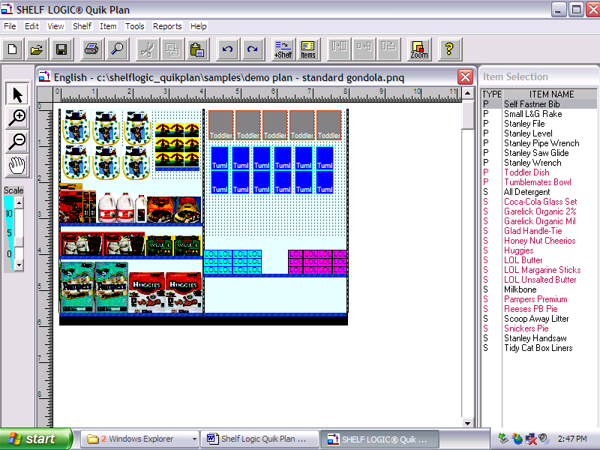
5. Rulers
- Tool
Bar
7. Status Bar
8. Scroll Bars

- Menu Bar – Contains all of the commands and features of Shelf Logic® Quik Plan.
- Button Bar – Shortcuts to some of the most frequently used commands.
- Plan Window – This is where you will construct and edit your plan.
- Item Selection Window – Displays your Items database.
- Rulers – Located above and to the left of the Plan Window to aid in the positioning of items and shelves. One inch on the ruler bar equals one foot of actual display.
- Tool Bar – Contains several useful tools for viewing, creating and editing your plan.
- Status Bar – Displays information about the selected item or shelf. When a shelf is selected (highlighted) the Status Bar will display the shelf dimensions. When an item is selected (highlighted) the Status Bar will display the item details.
- Scroll Bars – Used to scroll through the Plan or Items Windows when the display is too large to be viewed in one screen.

Button Bar
 | New - Opens a new planogram. If another planogram is currently open, an alert box will remind you to save it.
 | Open - Opens an existing planogram file.
 | Save - Saves the current planogram.
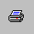 | Print – Opens the Print Dialogue Box.
 | Find - Finds items on the current planogram that match the selected item.
 | Cut - Cuts (removes) the selected item, shelf or group from the planogram.
 | Copy - Copies the selected item, shelf or group from the planogram.
 | Paste - Pastes a cut or copied object at the upper left corner of the Planogram Window.
 | Undo - Reverses the last action taken.
 | Redo - Restores the last Undo action.
 | Add Shelf - Opens the "Add Shelf" dialogue box.
 | Items – Opens Item Maintenance.
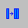 | Duplicate Right – Duplicates the selected item to the right.
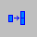 | Duplicate Up – Duplicates the selected item up.
 | Flip – Flips the selected item to one of 3 sides.
 | Zoom –Enlarge or decrease the view of the planogram.
 | Help - Opens the Help System.

Tool Bar
1
2
3

4

5

1. Arrow – Toggles between the normal arrow pointer and the zoom pointers.
2. +Magnify – (Zoom In) Turns the pointer into a magnifying glass to enlarge the view of a specific item, shelf or section of the plan (changes the display only, not the actual plan). Each mouse click enlarges the view by one increment.
3. -Magnify – (Zoom Out) Turns the pointer into a magnifying glass to shrink the view and display more of the plan (changes the display only, not the actual plan). Each mouse click shrinks the view by one increment.
4. Grabber Tool – Turns the pointer into a hand and moves the plan up/down or right/left within the Plan Window (an alternative to Scroll Bars).
5. Scale Slider – Re-scales the size of the view in the Plan Window (an alternative method for zooming in and out).

Detailed information about all of the above features can be found in
Sections 5 through 8.

How to Execute Commands

The many features of Shelf Logic® Quik Plan can be executed by using menus, keyboard shortcuts, button and tool bars, mouse clicks, or drag and drop. Before executing some commands, you must first select a shelf or item on which the command will be performed. Clicking the left mouse button on a shelf or item selects and highlights it in bright red.

Menus
There are two ways to execute commands from the menus:
- Using the mouse, click the menu name then click the command on the drop-down menu.
- Using the keyboard, hold down <Alt> and press the underlined letter in the menu name, then press the underlined letter in the command name.

Hot Buttons
The Hot Buttons located on the Button Bar are shortcuts to some of the more frequently used features. All of the Hot Button commands can also be found in the menus.

Shortcut Menus (Right Mouse Button)
In addition to the main menus, there are several shortcut menus that can be accessed by clicking the right mouse button over an object. These menus are object-sensitive, which means that the available options will be different depending upon the object you right-click on. We suggest experimenting with the right mouse button feature as much as possible. Once familiar with the different menus, you will find them to be considerable step-savers.

- Right clicking over a shelf will select the shelf and open a Shortcut Menu of commands relating to shelf arrangement.
- Right clicking over the plan area will open a Shortcut Menu of commands relating to display setup.
- Right clicking over an item in the Item Selection Window will select it and open a Shortcut Menu of commands relating to item maintenance.
- Right clicking over an item in the Plan Window selects it and opens a Shortcut Menu relating to item placement in the plan.

Double-Clicking an Object
Double-clicking an object in the plan window, such as a shelf or item, opens a maintenance menu that allows you to change the shelf dimensions or update the item in the database. Double-clicking the plan area opens the Display Setup dialogue box. Double-clicking an item in the Item Selection Window places the item on the plan.

Drag and Drop
Items can be dragged from the Item Selection Window and dropped onto the plan. To drag an item, select it from the Item Selection Window and hold down the left mouse button as you move the mouse. Release the mouse button to place the item on the plan.

When dragging and dropping an item, the Smart Shelf feature and Snap-To features still apply if turned on, but Next Available Location has no effect.

Keyboard Shortcuts
Some frequently used commands can be executed directly from the keyboard by holding down <Ctrl> or <Alt> and pressing a corresponding letter. If a particular command has a Keyboard Shortcut, it will appear on the menu next to the command name as follows: <Ctrl + letter>.

Reference List of Keyboard Shortcuts

Add Items to Database | <Ctrl +I>
Add Item to Planogram | <Ctrl + A>
Item Maintenance | <Ctrl + M>
File/Save | <Ctrl + S>
Open Existing Plan | <Ctrl + O>
Show Peg Holes/Turn Off Peg Holes | <Ctrl + H>
Show Photos/Turn Off Photos | <Ctrl + T>
Display Setup | <Ctrl + D>
Undo | <Ctrl + Z>
Redo | <Ctrl + R>
Cut | <Ctrl + X>
Copy | <Ctrl + C>
Paste | <Ctrl + V>
Find (Items on Planogram) | <Ctrl + F>
Zoom In | F8
Zoom Out | F7
Grabber Tool | <Shift> + Drag Mouse
Print Planogram | <Ctrl + P>
Scroll Forward through Item Maintenance | <Alt + D>
Scroll Backward through Item Maintenance | <Alt + B>
Exit Shelf Logic® | <Alt + F4>
Copy Selected Area | <Ctrl + Drag>

List of Menus & Commands

File Menu
New – Opens a new plan.
Open – Opens an existing plan.
Close – Closes a plan and clears the Plan Window.
Delete – Permanently deletes a plan from your hard drive.
Save – Saves the current plan.
Save As – Saves a copy of the current plan in a new file with a new name.
Unit of Measure − Toggles between English and Metric unit of measure.
Page Setup – Set page margins for planogram printouts.
Printer Setup – Change printers and printer options, such as paper orientation.
Exit – Closes Shelf Logic® Quik Plan.

Edit Menu
Undo – Reverses up to 10 operations.
Redo – Reverses the last Undo operation.
Delete – Removes one or more items or shelves from a plan.
Cut – Deletes an object and stores it in the clipboard for reuse.
Copy – Copies an object to the clipboard for reuse.
Paste – Places the clipboard contents in a new location.
Find – Finds and highlights matching items in a plan.
Copy Image to Clipboard – Copies the selected area of the plan to the Windows clipboard for pasting into another application.

View Menu
Show Ruler – Turns Ruler display on and off.
Show Button Bar– Turns Button Bar display on and off.
Show Tool Bar – Turns Tool Bar display on and off.
Show Pegholes – Turns display of pegholes on and off.
Show Shelf Numbers – Turns display of shelf number tags on and off.
Show Photos – Turns photo image display on and off.
Display Setup – Changes the plan configuration.
Scale – Changes the scale of the plan on the screen.
Zoom in – Enlarges the view of a section of the plan.
Zoom out – Shrinks the view to display more of the plan.
Preferences – Set defaults for some of the program features.
Info – Displays information about the current plan.

Shelf Menu
Add – Set shelf dimensions and adds one or more shelves to the plan.
Change – Changes shelf dimensions or placement of an existing shelf.

Item Menu
Maintenance – Add items or change existing items in the Items database file.
Flip – Turns an item onto one of 3 sides and displays the corresponding image.
Duplicate Up – Duplicates the highlighted item upwards.
Duplicate Right - Duplicates the highlighted item to the right.
Update from Database – Updates item details that have been modified since the plan was created.

Tools Menu
Arrow – Toggles between the normal arrow pointer and the Tool Bar pointers.
Magnify Up – (Zoom In) Turns the pointer into a magnifying glass to enlarge the view of an item, shelf or section of the plan (changes the display only, not the actual plan). Each mouse click enlarges the view by one increment.
Magnify Down – (Zoom Out) Turns the pointer into a magnifying glass to shrink the view and display more of the plan (changes the display only, not the actual plan). Each mouse click shrinks the view by one increment.
Grab – Turns the pointer into a hand and moves the plan up/down or right/left within the Plan Window (an alternative to Scroll Bars).

Report Menu
Print Planogram – Set print options for planograms.
Print Shelving Schematic – Set print options schematic printout.
Set Section Headers & Footers – Set headers and footers for planogram printouts.
Schematic Listing – Print or display information for constructing the actual shelving.
Product Listing – Print of display list of items on the display, quantities and placement.
Item File Detail – Detailed information about the Items database file.
Item File Summary – Item file listing can be used as an aid to product selection.

Help Menu
Contents – Opens the Help system.
About – Shelf Logic® version and release information.

Section 4 – Database Setup

Creating the Database

Shelf Logic® Quik Plan requires a minimal amount of initial setup, however, as with any new software, setup should be given careful consideration. Instructions for creating a database must be carefully followed. Data entry and product dimensions must be accurate. The quality of your final planogram is dependent upon an accurate, well-planned database.

..

Note: Be sure that all plan files are closed and that only the main Shelf Logic® Quik Plan application window is open (gray background). Many of the Hot Buttons and Menus will be inactive, however, the items database can still be accessed. If you previously had the sample files open during this working session, close Shelf Logic® Quik Plan and reopen it to access the items database.
☑

Entering Items into the Database

Item Maintenance Form
Hot Button: Items
Items Menu: Maintenance
Keyboard Shortcut: <Ctrl + I>

When you execute one of the above commands, the Item Maintenance form will open as shown below. The name and location of the active database file will appear on the title bar of the form—double check that you are using the correct database.

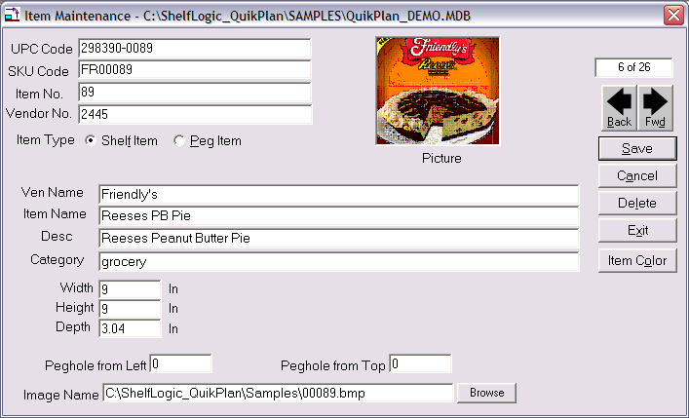
Figure 2 Item Maintenance

Each line in the form is called a field:
- use <Tab> to move forward one field,
- use <Shift +Tab> to move backward one field,
- or click the mouse inside the field to select it.

The UPC Code is the key field of the database and should always be entered first. If an item has already been entered using this UPC Code, the item details will fill the Item Maintenance form. The UPC Code must be unique for each item—duplicates are not allowed.

Some fields are required entries and some fields require data in a specific format. Each field has a maximum allowable number of characters. If a field is user-defined, that means numbers or letters are acceptable. Refer to the Item Maintenance chart below.

While your database is still in the planning stage, we suggest creating a practice planogram and printing out a sample of each report so you can see the effects of any empty or user-defined fields.

The following chart details the type of data to be entered when creating your database in Shelf Logic® Quik Plan:

Item Maintenance Field Chart
Field Name | Data Type | Maximum Characters | Description
UPC Code | Required  unique  alphanumeric entry | 25 | The industry standard Universal Product Code. This field is the primary (key) field, which Shelf Logic® Quik Plan uses to organize and locate items. It must be a unique number for each item—no duplicates are allowed.
SKU Code | Optional  user-defined | 25 | The manufacturer's identification code for the particular item.
Item No. | Optional  user-defined | 25 | Although this is an optional field, leaving it empty may have significant impact on your final results.
Vendor No. | Optional  User-defined | 25 | Code or number to identify the vendor that supplies this item.
Item Type | Required  select from radio buttons | 1  (“P” or “S”) | A Shelf Item is an object that can only be placed on a shelf. Placing a shelf item in a pegboard area will generate a warning message. A Peg Item can be placed on a shelf or hung from a hook.
Picture | Display – no entry needed | N/A | This will automatically display the image associated with this item.
Ven Name | Optional  User-defined | 50 | The full name of the vendor that supplies this item.
Item Name | Optional  user-defined | 50 | This name for this item

Field Name | Data Type | Maximum Characters | Description
Desc | Optional  User-defined | 50 | A detailed description of the item.
Category | Optional  User-defined | 50 | This field can be used to organize items by groups of related products for database filtering. Some reports are sorted by category.
Width | Required  Numeric | 12 | The width of the item (left to right) in inches. Enter whole numbers or decimals (1, 1.25, 1.5). Do not enter fractions.
Height | Required  Numeric | 12 | The height of the item (top to bottom) in inches. Enter whole numbers or decimals (1, 1.25, 1.5). Do not enter fractions.
Peg Hole From Left | Required for Peg Items –  Numeric | 10 | This field is only available when the Peg Item Type is selected. Enter the distance from the left edge of the package to the center of the peg hole. Enter whole numbers or decimals (i.e. 0.25, 0.5, 0.75, 1). Do not enter fractions.
Peg Hole From Top | Required for Peg Items –  Numeric | 10 | This field is only available when the Peg Item Type is selected. Enter the distance from the top edge of the package to the center of the peg hole. Enter whole numbers or decimals (i.e. 0.25, 0.5, 0.75, 1). Do not enter fractions.
Image File | Optional | 100 | Enter the path (location) and filename of the image file to be associated with this item. Clicking the browse button will allow you to select the file from the contents of your computer.
Record Counter – Located at the upper right corner of the Item Maintenance form, the record counter indicates the total number of records in the database.

Forward & Back Buttons – Used to scroll through the contents of the Items Database. This is an alternative to searching when you have a small database, and an alternative to the “Save” button to edit a record and continue scrolling.

Save Button - Once the required data has been entered, click the Save button (or use the keyboard shortcut of <Alt + S>). After clicking the Save Button, the Item Maintenance form will clear so that another item can be entered.

Cancel Button– Clears the screen without saving changes.

Delete – Deletes the current record from the Items Database.

Exit –Closes the Item Maintenance screen and returns to the main Shelf Logic®Quik Plan screen.

Item Colors - Click the Item Color Button to select a color scheme and pattern that will print in line art printouts and display on screen when photo images are turned off. Each item can have its own outline color, fill color, and pattern. If no color scheme is selected, a default of white with black outline will be used.

Tips for Creating an Effective Database
It is important to put some thought and planning into the initial setup of your database in order to achieve the best possible results. Following are some points to consider during the setup phase.

1. Enter a few test items and create some practice planograms.
- Print out the practice planogram and a sample of each report on the Report Menu.
- If you have left any fields empty, note the effect on reports, the Item Selection Window, the Plan Window, and planogram printouts.
- When entering your item dimensions, use the side most likely to face the front of the shelf. Although you can use the Flip Item feature to change the facing on your planogram, the dimensions entered into the database should be the ones most often used.
- We suggest color-coding items by category. This method helps organize your planogram and produces an attractive line art printout.
- Some changes to the Shelf Logic® database can have detrimental effects on existing plans. Never move or rename a database after it has been used to create any plans. Items deleted from the database will also be deleted from existing plans.

Working With Image Files

In order to use photographic images in your planograms, all you have to do is enter the item’s image file name and location in the Items database. Once entered, you should not move or rename image files and folders or you may have to recreate these links. Image files can be stored on any drive and in any folder, however, we recommend storing them in the Images subfolder created during installation of Shelf Logic® Quik Plan.

Image File Formats
Shelf Logic® Quik Plan supports both bitmap and JPEG image file formats.
A bitmap is a graphic image saved in the standard Windows graphic file format. Bitmaps are accepted by all Windows applications and generally produce the best quality photographic printouts, but bitmap files can be very large.

A JPEG file is another graphic image format commonly used for web pages, electronic transfer (email), and printed documents. JPEG files are smaller, transfer more quickly, and require less storage space.

You will achieve the best print quality with original images created in either bitmap or JPEG formats. Converting images from one format to another can cause a loss of detail and print quality.

If you are going to use photographic images or custom shapes with your plans, we suggest that you have access to a graphics software program that can perform the following functions:

- Convert files from other formats to bitmaps or JPEG’s if necessary.
- Resize or resample color images – Shelf Logic® Quik Plan will automatically scale the bitmap image to the proper size for the planogram, however, if the image is too large or too small, print quality may be affected. The recommended size is approximately 100 to 400 pixels height or width, with the second dimension proportionate to the first.
- Cropping – the photograph should be taken straight on and never at an angle. Crop as close as possible to the edges of the actual item, removing as much excess background as possible.
- Change background color – since the printed planogram background is white, the graphic image background should also be white.
- Drawing tools for creating shapes.

Maintaining the Items Database

Editing the Item Maintenance Form
Menu: Item/Maintenance
Hot Button: Items

Executing one of the above commands will open an empty Item Maintenance screen to enter a new item or edit an existing one. Locate the item you wish to edit using one of the following methods:

- Select the item on the planogram, right-click and select Edit Item.
- Double-click the item on the planogram.
- Locate the item in the Items Window, right-click and select Edit Item.
- Open Item Maintenance and search the database for the item.

Saving Changes to the Items Database
After making changes to an existing item click the Save button to save the changes and clear the Item Maintenance form; or, click the right or left scroll button to save the new record and proceed to the next record. Once an existing item has been edited, Shelf Logic® Quik Plan will automatically insert the current date in the Last Change Date field.

Editing the item’s UPC code will create a duplicate item with a new UPC code. The original item will remain unchanged.

Deleting an Item From the Database
After locating the item in the database, click the Delete button. Deleting an item in this manner permanently erases the item from the database.

☑
Note: Certain changes to an existing database can have detrimental effects on plans previously created with that database.

Update From Database
Menu: Item/Update from database

When a plan file is opened, Shelf Logic® Quik Plan automatically checks the database for possible changes in three areas:

- Does the item on the plan still exist in the current database?

- If the item has been deleted, a warning dialogue box will open listing the deleted UPC codes and deleted items on the plan will be marked with a large black X as shown below. This item cannot be updated and should be removed from the plan.

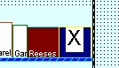

Figure 3 Deleted UPC Code
- Are the length, width and depth of the items on the plan the same as in the current database?

- If not, the item is marked with a large black exclamation point as shown below.

- Are the peg hole locations (left and top) the same as in the current database?

- If not, the item is marked with a large black exclamation point as shown below.

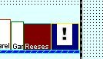

Figure 4 Changed Item Dimensions
The Update from Database command can be executed by selecting the above menu command, or by right-clicking the item on the plan. The selected item will be updated to reflect the new information in the database. The item's position may then need to be adjusted manually.

Using the Items Database

The Item Selection Window
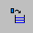
When a new plan is created or an existing plan opened, the Item Selection Window will appear to the right of the Plan Window and display the active database. The Item Selection Window is automatically sized and positioned to fit within the main Shelf Logic® window.

Both the Plan Window and the Item Selection Window can be resized by dragging the window’s edge. Place the mouse pointer over the right edge of the Plan Window and the left edge of the Items Window. When the pointer becomes a double-headed arrow, drag to resize both windows for a perfect fit.

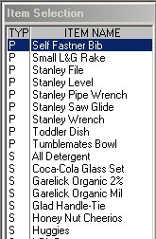

Figure 5 Item Selection Window

Items are listed in the Items Window in order of Item Type. Peg items are listed at the top and are preceded by the letter “P”; shelf items follow and are preceded by the letter “S”. The Item Number is the default display field, however, you can easily change the display field to UPC Code, SKU Code, Item Name or Description. To change the default Item display field:

- Place the mouse pointer inside the Items Window and right-click.
- Select the desired display field from the menu.

When you change the display-by field, your selection becomes the new default and will remain in effect until the next time you change it. The display-by field can also be set in Preferences. The selected display-by field and item number print on line art planograms.

To locate an item in the Item Window, click the mouse inside the window and type the first letter or number of the item. The curser (highlighted bar) will jump to the beginning of that section; or use the scroll bars to scroll through the list. When working with a large database the Filter Feature (see below) can be used to restrict the items that appear in the Item Selection Window for easier selection.

Once an item has been added to a planogram, the text color for that item will turn red, indicating that the item has already been selected. Removing that item from the planogram will restore the text color to black.

Section 5 – Creating a Display

Display Concepts
This chapter will introduce the basic concepts of creating a planogram. Additional features of Shelf Logic® Quik Plan are covered in Sections 6, 7 and 8.

The steps for creating a planogram are really very simple:

1. Define the display type and dimensions.
2. Add shelves to the display.
3. Add items to the display.

Your items are represented on the planogram by a scaled line art box, a custom shape, or a photographic image. Items can be placed anywhere on the planogram, however, warning messages will alert you when an item is not properly positioned, or if there is not enough space.

There are three display types in Shelf Logic® Quik Plan:

- Shelf/Peg is used to create a shelving planogram, a pegboard planogram, a combination shelf/pegboard planogram, or pallet rack planogram.
- Slat wall is used to create a horizontal slat wall planogram.
- Vertical Slide is used to create a planogram where items are displayed on vertical fixtures such as waterfall hooks or literature racks.

Once the Display Setup is complete, the new planogram will appear in the Plan Window. The Items Database will open in the Items Selection Window.

Shelf/Peg Display Setup
Hot Button: New Plan
Menu: File/New

After executing one of the above commands, the Display Setup dialogue box will open as shown below. A typical gondola display setup is shown:

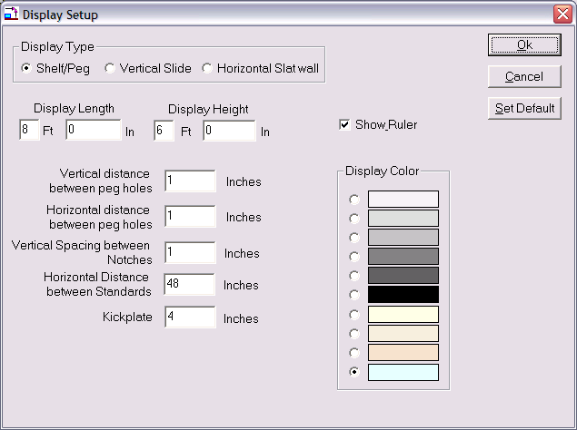

Figure 6 Display Setup Shelf/Peg
Type
Select Shelf/Peg to create a shelving display, a pegboard display, or a combination shelf and pegboard display.
Display Length & Display Height
These dimensions will determine the total area of your display. Measurements can be entered in feet, feet and inches, or all inches.
Vertical Distance & Horizontal Distance Between Peg Holes
These measurements determine the type of pegboard used for the display background. A minimum of .5” must be entered. Standard pegboard is one inch vertical by one inch horizontal. If you prefer not to have a pegboard background, you can turn off the peg holes later from the View Menu.
Vertical Spacing Between Notches
This is the vertical distance between the slots on the vertical uprights into which the shelves will be attached. One inch is standard for most gondola or wall shelving. With one-inch slot positions, shelf height and shelf movement must be in one-inch increments. With two-inch slot positions, shelf height and shelf movement must be in two-inch increments.

Kickplate
This is the height of the kickplate or base unit. The kickplate appears as a solid black area at the bottom of the display. The top of the kickplate is the lowest possible position where a shelf may be placed, but it is not an actual shelf and cannot hold items.

Display Color
Select a background color for the display. This color is for on-screen viewing only and does not affect printed planograms. The printed planogram will have a white background to accommodate photographic images.

OK Button
Accepts the current setup, closes the Display Setup box, and opens the display in the Plan Window.
Cancel Button
Closes the Display Setup box without creating a new display or saving changes to an existing display.

Set Default
Clicking the Default button will save the current display setup. Each new planogram will begin with these dimensions, however, they can be changed as needed. Each time you click the Default button, the current setup will overwrite the previous one saved, but will not affect any planograms created previously.

Your basic display should now be visible in the Plan Window. Drag the Scale Slider Button on the Tool Bar to scale the view to your preference. When learning the program, it’s usually easier to position items and shelves in a larger scale.

Horizontal Slat Wall Display Setup
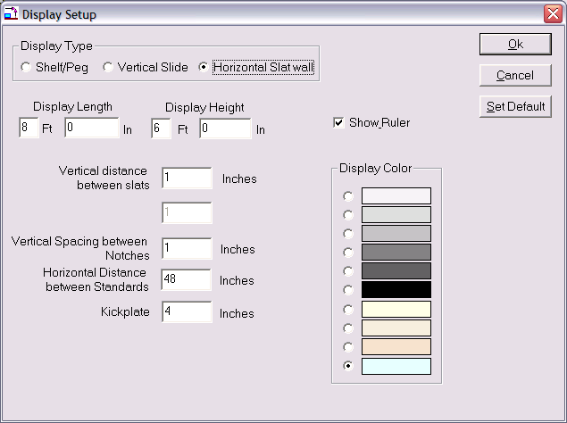
Figure 7 Display Setup Slat Wall

Type
Select Horizontal Slat wall.

Display Length & Display Height
These dimensions will determine the total area of your display. Measurements can be entered in feet, in feet and inches, or all inches.

Vertical Distance Between Slats
Measure the distance from the top of the channel to the bottom of the slat. Standard slat wall has a vertical distance of 3 inches.

Vertical Spacing Between Notches
Use the default setting of 1.

Kickplate
This is an optional setting for slat wall that can be set to 0 if no base is needed.

Display Color
Select a background color for the display. This color is for on-screen viewing only and does not affect printed planograms. The printed planogram will have a white background to accommodate photographic images.

OK Button
Accepts the current setup, closes the Display Setup box, and opens the display in the Plan Window.

Cancel Button
Closes the Display Setup box without creating a new display or saving changes to an existing display.

Set Default
Clicking the Default button will save the current display setup. Each new planogram will begin with these dimensions; however, they can be changed as needed. Each time you click the Default button, the current setup will overwrite the previous one saved, but will not affect any planograms created previously.

Your slat wall display should now be visible in the Plan Window. Drag the Slider Button on the Tool Bar to scale the view to your preference.

You are now ready to add shelves, floating shelves or items to the slat wall display.

Vertical Slide Display Setup
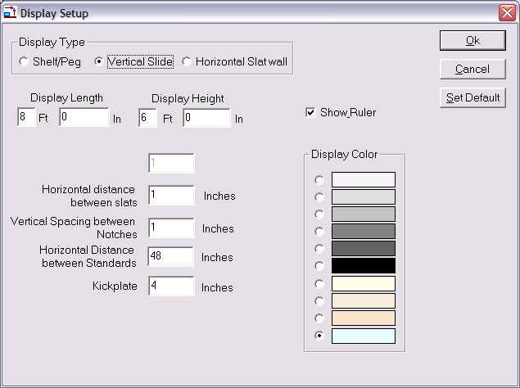
Figure 8 Display Setup Vertical Slide
Type
Select Vertical Slide.

Display Length & Display Height
These dimensions will determine the total area of your display. Measurements can be entered in feet, in feet and inches, or all inches.

Horizontal Distance Between Slats
Measure the distance from the left edge of the first vertical fixture to the left edge of the next vertical fixture.

Vertical Spacing Between Notches
This is the vertical distance between slots on the vertical uprights into which shelves or racks will be attached.

Kickplate
This is an optional setting for Vertical Slide.

Display Color
Select a background color for the display. This color is for on-screen viewing only and does not affect printed planograms. The printed planogram will have a white background to accommodate photographic images.

OK Button
Accepts the current setup, closes the Display Setup box, and opens the display in the Plan Window.

Cancel Button
Closes the Display Setup box without creating a new display or saving changes to an existing display.

Set Default
Clicking the Default button will save the current display setup. Each new planogram will begin with these dimensions; however, they can be changed as needed. Each time you click the Default button, the current setup will overwrite the previous one saved, but will not affect any planograms created previously.

Your vertical display should now be visible in the Plan Window. Drag the Slider Button on the Tool Bar to scale the view to your preference.

You can now begin adding shelves or items to the display.

Working with Shelves

Adding Shelves to a Display
Hot Button: +Shelf
Menu: Shelf/Add

After executing one of the above commands, the Add Shelf dialogue box will open as shown below. Shelves are always added to the display from the bottom up and can be added individually or in multiples. Shelves should never be longer than the section length defined in display setup.

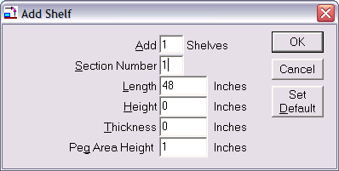

Figure 9 Add Shelf
Add__ Shelves
Enter the number of shelves to be added to the active section.

Section Number
Always defaults to the active section. The active section is the last section in which the mouse was clicked. You can change the default section number if necessary.

Length
This is the length of the shelf in inches from left to right. This measurement defaults to the length of the section as defined in Display Setup and cannot be changed.
☑
Note: If you need to add a shelf that is shorter or longer than the section length, the floating shelf feature should be used.

Height
This is the shelf height, the distance from the top surface of the current shelf to the bottom surface of the shelf above it. This is the area reserved for items and will appear as a shaded area on the screen.
☑
Note: The top shelf of each section will still have the specified shelf height reserved for items even though there is no shelf above it, as indicated by the shaded area.

Thickness
This is the thickness of the shelf.

Peg Area Height
If desired, there can be a peg area above the shelf and below the shelf above. The peg area starts on top of the specified shelf height.

The shelf above will start after the peg area, so if you have a 6 inch shelf height and a 6 inch peg area, then there’s a total of 12 inches between the shelves.

If you don’t want a peg area above a shelf, then make the peg area height 0.

OK Button
Accepts the shelf dimensions, closes the Add Shelf dialogue box, and adds the shelf or shelves to the display in the Plan Window.

Cancel Button
Closes the Add Shelf dialogue box without adding shelves.

Default
Saves the current shelf dimensions as the default shelf setup.

The defined shelves should now appear on the display and are colored blue. To select a specific shelf, place the mouse pointer over the shelf and click the left mouse button. The selected shelf turns red.

The shaded area above the shelf is a visual aid for determining the space occupied by each shelf. Even though you will not see the pegboard background in this reserved area on your screen, you can still place peg hook items in the reserved area. When a peg item is placed with its bottom edge on a shelf, the item automatically becomes a shelf item as indicated on the Status Bar.

Adding a Floating Shelf to Pegboard or Slat Wall
A floating shelf is attached directly to pegboard or slat wall instead of to vertical uprights, and can be used to simulate many different pegboard or slat wall accessories. Floating shelves can be used with any display type and can be dragged to any position within the display.

The procedure for adding a floating shelf is identical to adding a regular shelf, except that the Section Number must be zero. A floating shelf can be any length since it does not attach to uprights.

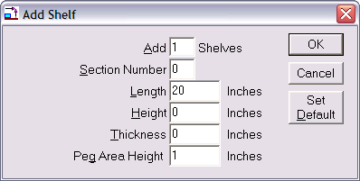
Figure 10 Floating Shelf Setup

Editing a Shelf
There are several ways to access the Change Shelf dialogue box:
- Double-click the shelf you wish to edit.
- Right-click over the shelf and select Change Shelf.
- With a shelf selected, click the Shelf Menu and select Change.
Shelf height can also be adjusted by dragging shelves up and down along the vertical uprights, or to a new section.

The following display uses a full-sized base shelf and 3 floating shelves. Notice how the floating shelves attach directly to the pegboard instead of the standards.

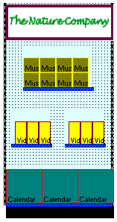

Figure 11 Three Floating Shelves with 1 base shelf.

Show Shelf Numbers
Menu: View/Show Shelf Numbers

Selecting this option turns the display of shelf number tags on and off and is particularly useful when working with Smart Plan for Shelves.
☑
Note: If you have rearranged the shelf positions it is possible that the shelf numbers will not be in consecutive order on your planogram.

How Shelves are Placed on the Plan

When first adding shelves to a section, the shelves are placed from the bottom up. The first shelf is placed so that the top of the shelf is level with the top of the kickplate, or if no kickplate, the shelf top is level with the bottom of the display, the bottom of the shelf actually hangs below the display. In a reality, the top of the kickplate if the first shelf.

From the first shelf, the shelf height extends upwards and if there’s a peg area height specified, then that extends upwards after the shelf height. After that comes the second shelf.

For example, the shelf height of the first shelf is 12 inches and the peg area height is 6 inches. So there’s a total of 18 inches in between the shelves. The bottom of the second shelf starts at 18 inches up, and if this second shelf thickness is an inch, then the top of the second shelf is 19 inches above the top of the first shelf.

If you specify a “Distance from the bottom”, then the shelf will start at this location, regardless of shelf heights and peg area heights.

Moving Shelves
This is where the “logic” in Shelf Logic comes in. The shelves act in very specific ways to help you in moving them around the display, and lend themselves to trying different display scenarios. Much of this behavior is controlled by the Smart Shelf feature.

When Smart Shelf is turned off, then after the shelves are moved, the shelves remain in place but their shelf height and peg area height are adjusted to fit the newly placed shelves.

With Smart Shelf turned on, then after the shelves are moved, the position of the shelves above the moved shelves are moved up or down so the shelf height and peg area height remain the same.

If there isn’t enough room for the changes requested, in other words, not enough room at the top to push shelves upwards, you will get an error message and the move will be undone.

Some examples will make this clearer.

Moving Shelves Up in the Same Section – Smart Shelf Off

With Smart Shelf off, a moved shelf will stay where placed and its shelf height and peg area adjusted according to the location of the shelf above. Let’s look at an example of this.

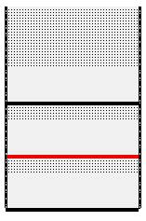
Figure 12. Before Moving a Shelf – Smart Shelf Off

In figure 12, we have three shelves, each with a shelf height of 12 inches and a peg area height of 6 inches. The middle shelf is selected and will be moved upwards, as shown in the next figure.
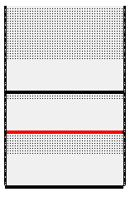
Figure 13. Moving the Shelf Upwards – Smart Shelf Off
The shelf has been moved upwards slightly. Since Smart Shelf is off, the moved shelf’s height and peg area are not preserved. As the shelf is moved upwards, first the peg area height is reduced and when there’s no more peg area, then the shelf height is reduced, as shown in the next figure.

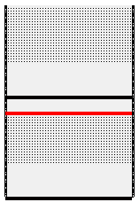
Figure 14. Moving the Shelf Up More – Smart Shelf Off
Here, the middle shelf has been moved up even more, and since there’s no more peg area, then the shelf height of the moved shelf is reduced.
If there was never a peg area height specified, then only the shelf height is reduced as the shelf is moved upwards.

Moving Shelves Up in the Same Section – Smart Shelf On

With Smart Shelf on, a shelf stays where placed, but the shelves above this shelf are pushed upwards so the shelf height and peg area of the moved shelf remains unchanged. In other words, as the shelf is moved, the other shelves move out of its way. Let’s look at an example.

Figure 15. Before Moving a Shelf U[wards – Smart Shelf On
Here are three shelves before the move. The middle shelf is selected and will be moved upwards. Since Smart Shelf is on, the shelf above the selected shelf will move upwards along with the selected shelf, as shown in the next figure.

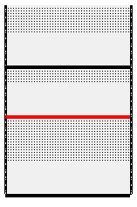
Figure 16. After the Shelf Move – Smart Shelf On
In the figure above, you can see that the middle shelf is moved upwards and the shelf above it is also moved the same amount, so that the shelf height of the moved shelf remains at 12 inches and the peg area height of the moved shelf remains at 6 inches.

Moving Shelves Down in the Same Section – Smart Shelf Off

When moving a shelf downwards with Smart Shelf off, then the shelef height and peg area of the moved shelf increases and the shelf height and peg area of the shelf below is reduced. Let’s look at an example.

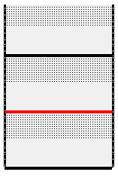
Figure 17. Before Moving a Shelf Down – Smart Shelf Off

Here are three shelves before the move. The middle shelf is selected and will be moved downwards. Since Smart Shelf is off, them the shelf heights are adjusted to fit the new shelf locations.

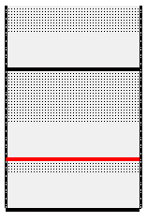
Figure 18. Moving the Shelf Downwards – Smart Shelf Off
As the middle shelf is moved down, its shelf height remains the same but the peg area is increased. If there’s no peg area, then the shelf height is increased. Below the moved shelf, the peg area is reduced for the shelf below. As the shelf is moved down, first the peg area is reduced, and when there’s no more peg area, then the shelf height is reduced, as shown in the figure below.

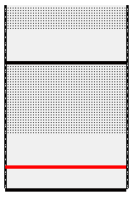
Figure 19.The Shelf is Moved Down More - Smart Shelf Off

In the above figure, the shelf is moved down enough so that the shelf height of the shelf below is reduced.

Moving Shelves Down in the Same Section – Smart Shelf Off

When Smart Shelf is on, then as shelves are moved downwards, the position of the shelves above are changed to fit the existing shelf heights and peg areas. Here’s an example:

Figure 20. Before Moving a Shelf – Smart Shelf On
Here are three shelves, with the middle one selected for the move. When the shelf is moved down, the top shelf is also moved down, so that the shelf height and peg area height of the selected shelf remains the same.

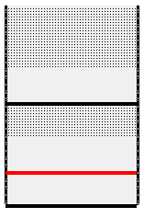
Figure 21. After Moving a Shelf – Smart Shelf On
The shelf height and peg area of the moved shelf remains the same as before the move. The shelf height and peg area of the shelf below are reduced. The top shelf is moved downwards the same distance as the selected shelf, keeping the shelf height and peg area height of the selected shelf constant.

Overlapping Shelves

You can drag a shelf past another shelf. With Smart Shelf off, the shelf heights are adjusted, with Smart Shelf on, the shelf positions are adjusted.

You can insert a shelf in between two other shelves. The shelves above will move up and make room for the selected shelf and any items you might have on that shelf.

Moving Shelves Left and Right

You can move shelves to other sections of the plan. It is suggested that you turn Smart Shelf on when doing this so that any shelves in the way are adjust to make room for the moved shelf and items on that shelf.

With Smart Shelf off, the moved shelf will have its shelf height and peg area adjusted after being moved to the new section, depending on the positions of the shelves already placed in that section.

Working With Items

The Items Selection Window
The Items Window should appear to the right of the Plan Window. If it is not visible, click the +Items Button on the Button Bar. The Items Window is automatically sized and positioned to fit within the main Shelf Logic® window.

Both the Plan Window and the Items Selection Window can be resized by placing the mouse pointer over the right edge of the Plan Window and the left edge of the Items Window then dragging the double-arrow mouse pointer.

Items are listed in the Items Window in order of Item Type. Peg items are listed at the top and are preceded by the letter P, followed by shelf items.

Display-By Fields
The Item Number is the default display field, however, you can easily change the display field to UPC Code, SKU Code, Item Name or Description.

To change the default Item display field:

- Place the mouse pointer inside the Items Window and right-click.
- Select the desired display field from the menu.

Note: Unlike previous versions, the Display-By field now affects both the screen display and the planogram printout. When printing a planogram with line art and text, the Item Number field and the selected Display-By field will both appear on screen and on the printout.
☑

When you change the display-by field, your selection becomes the new default and will remain in effect until the next time you change it. The display-by field can also be set in Preferences.

Photo Images
View Menu: Show Photos
With the Photo Image feature turned on, you can build your planograms using actual photo images. For the purpose of speed and convenience, you can switch between line art mode and photo mode at any time by clicking on the above menu option.
- If there is no image associated with a particular item, a line art box will be substituted.
- If an item has a custom shape associated with it, the custom shape will appear on the planogram in line art mode only.
- If an item has both an image and custom shape, the shape will appear in line art mode and the image will appear in photo image mode.

Adding Items to the Planogram
Menu: Item/Place
Keyboard Shortcut: <Ctrl + A>
Mouse: Double-click the Item
Drag & Drop the Item

Items can be added using any of the above methods, however, double-clicking in the Item Window is usually the method of choice.

Placing Items on Shelves
Both shelf item types and peg item types can be placed on shelves. If a shelf item is not properly positioned on the shelf, or does not fit in the selected position, a warning message will alert you.

Placing Items on Hooks
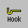
Hot Button: Hook
Display Setup: Hook Size
Menu: Item/Change Hook Length

Only peg item types can be placed on hooks. Peg items are added in the same manner as shelf items. Peg items will appear at the upper left corner of the Plan Window and are then dragged into position. When positioning a peg item on the planogram, the item will automatically snap to the nearest available peg hole. You cannot place a peg item where there is no peg hole to accommodate the hook.

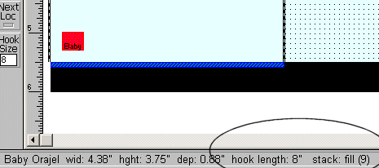

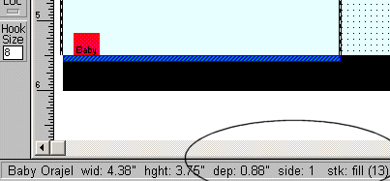

Figure 12 Peg item on hook and same peg item on shelf.

Duplicating Items
Hot Button: Dup Right
Dup Up
Menu: Item/Duplicate Right
Item/Duplicate Up

Once you have items on the planogram, you can duplicate them using one of three methods. With a little practice, you will discover which method is best suited to each situation.
Duplicate Up and Duplicate Right
The Duplicate Up Command will copy a selected item facing and stack the copy on top of the original. You can Duplicate Up repeatedly until you run out of space. The Duplicate Right command works the same way, but will place the copy to the right of the original. This is the easiest method for duplicating facings of items.

Flipping Items
Hot Button: Flip
Menu: Item/Flip
An item on the planogram can be flipped onto one of three sides. Executing one of the above commands will flip the selected item to the next side. The Status Bar will display the current side number and corresponding dimensions. If 3-sided image files are used, the appropriate image will be displayed for each side.
The Flip feature is useful for filling excess space at the end of a shelf. By shutting off Smart Shelf and Next Loc, you can manually add an item and flip it until it fits the available space.

Grouping Items
You can select a group of items, or items and shelves, by drawing a lasso (a dashed line) around the items. You only need to include a portion of an item in the lasso to include it in the grouping.
To draw a lasso around a group:
- Position the mouse pointer just outside one corner of the group.
- Hold down the left mouse button and drag the mouse so that the lasso forms around each item, or a part of each item. The mouse can be dragged up, down, left, right or diagonally.
- Release the mouse button.

When the mouse button is released, all of the items in the group will be selected (red). The group can then be moved, copied or deleted.

To de-select a group, click anywhere outside of the group.

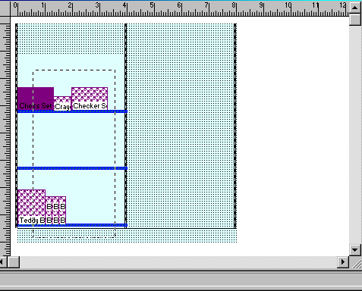
Figure 13 Drawing the Lasso
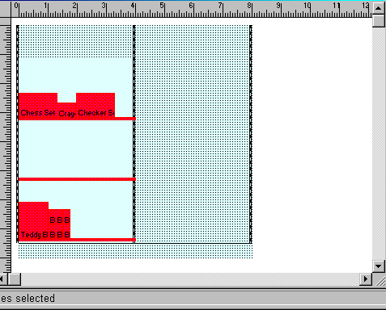
Figure 14 The Group Formed by the Above Lasso

Deleting Items and Shelves
You can delete a single item or group of items, including shelves. Select the item or group and click the Cut button on the Button Bar, or right-click and select Delete from the menu. The deleted item is temporarily stored in the clipboard for reuse.
A shelf cannot be deleted if there are items on it. The items must first be moved, deleted, or grouped with the shelf.

Section 7 – Editing Features

Editing Display Setup
The display dimensions of a planogram can be edited through the Display Setup dialogue box at any time. Double-click on an empty section of the planogram, or right-click and select Display Setup. Keep in mind that some changes to Display Setup may have significant impact on a planogram that is already under construction. We suggest saving your planogram before making any changes to the setup since you cannot use the Undo feature on changes to Display Setup. To restore the display to the previous configuration, close the file without saving changes and then re-open it.

Section 8 – Other Features

Cut/Copy/Paste
Another way to duplicate items and/or shelves is by using the standard Windows Cut, Copy & Paste features. After cutting or copying an item, it can be pasted repeatedly into different locations on the planogram.
The Cut Command
Hot Button: Cut
Menu: Edit/Cut
Keyboard Shortcut: <Ctrl + X>
Upon executing one of the above commands, the selected shelf and/or items are removed from the original location and can be pasted into a new location. The Cut command is different from the Delete command in that Cut stores the objects for reuse and Delete removes the objects from the plan permanently.
The Copy Command
Hot Button: Copy
Menu: Edit/Copy
Keyboard Shortcut: <Ctrl + C>
The Copy command works the same way as the Cut command except that it copies the selected items/shelves, leaving the originals in place. Copies can then be pasted into a new area of the planogram.
The Paste Command
Hot Button: Paste
Menu: Edit/Paste
Keyboard Shortcut: <Ctrl + V>
The Paste command will place the contents the cut or copied items into the upper left corner of the Planogram Window. Pasted items will be highlighted so that you can move them into place. You can use the Paste command repeatedly.
Duplicate Copy
Another way to create duplicates is to select a shelf, an item, or a group, and hold down <Ctrl>, while dragging the selection to a new location on the planogram. As you drag, the original selection stays in place and the duplicate moves along with the mouse pointer to the new location. This method is best used when duplicating groups.
Copy Image to Clipboard
This command will copy the selected items and/or shelves to the Windows clipboard for pasting into other documents, such as MS Word or Excel.

Undo Feature
Hot Button: Undo
Menu: Edit/Undo
Keyboard Shortcut: <Ctrl + Z>
Each time one of the above commands is executed, your plan reverts back one action. You can click Undo up to 10 consecutive times. Actions that can be undone are:
- Moved shelves and items
- Deleted shelves and items
- Items placed on the planogram
- Updates from database (see Section 4)
- Cut and Paste

Redo
Hot Button: Redo
Menu: Edit/Redo
Keyboard Shortcut: <Ctrl+R>
Redo reverses the last Undo operation. You can Redo up to the last 10 Undo operations. If you delete a shelf, the Undo command would restore the deleted shelf. The Redo command would delete the shelf again. With Undo and Redo, you can go backward and forward through changes made to your planogram.

Finding Items on the Planogram
Hot Button: Find
Menu: Edit/Find
Keyboard Shortcut: <Ctrl + F>
The Find feature locates and highlights all matching items on a planogram. If an item on the planogram is selected, it is assumed that this is the item to match. Executing one of the above commands will locate and highlight items in the plan that matches the selection.
If no item is selected, the Find box will open as shown below. Enter a UPC Code, SKU Code, Item Code, Item Name or Category to locate matching items.
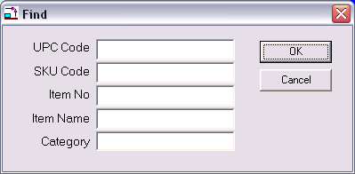

Figure 15 Find Item

Plan Information
Menu: View/Info
The View Info command displays the plan’s vital statistics such as the number of shelves and items, the name of the database used, and the version of Shelf Logic® Quik Plan used to create the plan. This information is especially useful when reviewing older plans.

Version Information
Menu: Help/About
Upon executing the above command, a dialogue box will open and show which Shelf Logic® product and version is currently running.

Viewing Features

Shelf Logic® Quik Plan has several features to customize the way the main screen is displayed. When working with large plans, turning off rulers, button bars, and tool bars will maximize the viewing space.
The following features can be turned on or off at any time during a work session from the View Menu:

Customizing the Screen Display

Show Ruler
Menu: View/Show Ruler
One inch on the ruler bar equals one foot of display space. When the rulers are turned off, you will have more working space in the Plan Window, however, you will not be able to create guidelines.

Show Button Bar
Menu: View/Show Button Bar
The Hot Buttons on the Button Bar are shortcuts to some of the more frequently used commands. Turning off the Button Bar provides more working screen space. Commands normally executed from the Button Bar can be executed from menus when the Button Bar is turned off.

Show Tool Bar
Menu: View/Show Tool Bar
Like the Button Bar, the Tool Bar also contains shortcuts to frequently used commands and features. These can be executed from menus when the Tool Bar is turned off.

Show Pegholes
Menu: View/Show Pegholes
When this is turned off, pegholes will not be visible on screen, but will still control the placement of items on the pegboard sections of the planogram. Turning off peghole display also turns them off on the planogram printout.

Scale, Zoom and Scrolling Features
There are several features that will change the scale of your plan as displayed on the screen. Scaling allows you to view more of the plan by scaling it down to a smaller size, or to enlarge a particular area for closer inspection. There are 10 possible scaling positions that range from 1½: 1 to 63:1.
The scaling feature is based upon a monitor resolution of 640x480, which is the recommended resolution when working in Shelf Logic® Quik Plan. If you do not know how to change your monitor’s resolution in Windows, contact your System Administrator for assistance.
Because Scaling and Zooming are extremely useful tools, there are several alternative features available. Which feature you use will be based upon the particular situation and personal preference.

Changing the View Scale
Hot Button: Zoom
Menu: View/Scale
Tool Bar: Scale Scrollbar
Upon executing one of the above commands, the Viewing Scale dialogue box will open as shown below:
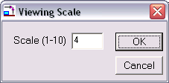
Figure 16 Viewing Scale
Enter a preset scale option by entering a number from 1 to 10. A scale of 1 makes the plan the smallest while 10 enlarges it to maximum size.

The Scale Scrollbar located on the Tool Bar at the left of the screen is an alternative method of setting the scale without using the dialogue box. Dragging the Slider Button will change the scale up or down to one of the 10 settings. For more exact scaling, clicking on the Scroll Arrows located above and below the scrollbar will increase or decrease the scale by an increment of 1 for each click.
Zoom In/Zoom Out
Menu: View/Zoom In
View/Zoom Out
Keyboard Shortcut: <F8 Key> Zooms In
<F7 Key> Zooms Out
The Zoom features work in much the same way as scaling. Zooming In will increase the scale in increments of 1 each time the command is executed. Zooming Out will decrease the scale in increments of 1 each time the command is executed.

Magnify Feature
Tool Bar: +Magnify Button
-Magnify Button
The Magnify Features allow you to select a specific item, shelf or section of the plan to zoom into or out of without the need for scrolling.
Clicking on one of the Magnify Buttons located on the Tool Bar will turn the mouse pointer into a Magnifying Glass. You can then click on the section of the plan you want to focus on. Each click will increase or decrease the scale factor by 1 increment. The Magnify feature will remain in effect until you deselect it by clicking on the pointer arrow at the top of the Tool Bar. This returns the mouse pointer to the standard arrow mode.

Scrolling Through the Plan
Depending upon the scale setting, you may not be able to view the entire plan in the Plan Window. There are two ways of scrolling to view areas of the plan not visible at the current scale.
Standard Scroll Bars
The horizontal and vertical Scroll Bars, located at the bottom and right edges of the Plan Window, are used to scroll through the Plan Window. The following figure demonstrates the various elements of a standard Scroll Bar:
Scroll Bar Slider
Scroll Bar

Scroll Buttons

Figure 17 Scroll Bar

Scroll Buttons – Each click will scroll left, right, up or down by 1 increment.
Scroll Bar Button – Indicates your relative position within the Plan Window. The Scroll Bar Button can be dragged with the mouse to scroll through the window.
Scroll Bar - Clicking on the vertical Scroll Bar above or below the Scroll Bar Button will scroll by a larger increment (or left/right on the horizontal Scroll Bar).
Grab Tool
Tool Bar: Hand Button
Keyboard Shortcut: <Shift Key>+ Drag Mouse
The Grab Tool is an alternative to using Scroll Bars. When the Grab tool is in effect, the mouse pointer changes to a hand. Position the hand inside the Plan Window and drag the screen up, down, left, or right to the desired view.
If the Tool Bar is not currently showing, you can activate the Grab Tool by holding down the <Shift Key> while dragging the mouse. Releasing the left mouse button returns the pointer to the standard arrow.

Section 9 – File Management

Saving Plans

Name and Save a New Plan
Hot Button: Save
Menu: File/Save
Keyboard Shortcut: <Ctrl + S>
We recommend naming and saving a new plan as soon as you have defined the layout, and also performing frequent saves throughout your work session. This will prevent the loss of your work should an operating problem or user error occur.
After executing one of the above commands, the standard Windows File Save dialogue box will open as shown below. You should accept the default save location in the Shelflogic_QuikPlan/DataFile folder.

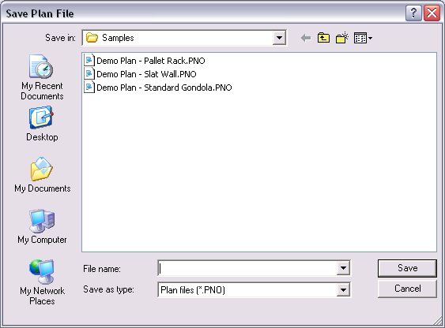
Figure 18 Save Plan

Enter a file name for the new plan. Long files names are acceptable. Do not include the period and 3-letter extension in your file name. The file extension of .PNO will automatically be added by Shelf Logic® Quik Plan. Click the OK Button to save the file.

Opening an Existing Plan
Hot Button: Open
Menu: File/Open
Keyboard Shortcut: <Ctrl + O>
Once you have named and saved a plan, you can reopen it for editing at any time. After executing one of the above commands, the standard Windows Open File dialogue box will open as shown below. Select a plan from the list in the left window and click the OK Button to open it. The database used to create this plan will also open.
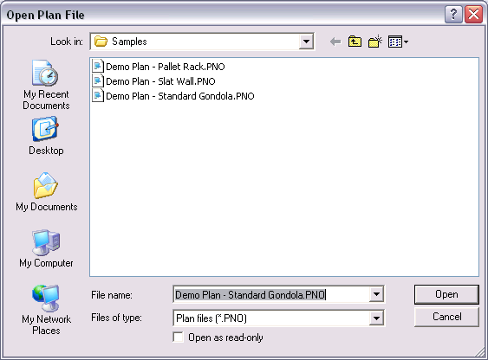
Figure 19 File Open

Saving a Copy With a New Name
Menu: File/Save As
After making changes to an existing planogram, you may want to save the changes in a new file, leaving the original planogram unchanged. This is a good way to make several different versions for comparisons. By saving your plan frequently under different names you can always revert to an earlier version.
After executing the above command, the standard Windows Save As dialogue box will open. Enter a new file name in the File Name box. Long file names are acceptable. Do not add the period and 3-letter extension. Click the OK button to save the file. The original file will close and the newly named file will become the active planogram file.

Closing a Plan
Hot Button: Windows Close Button
Menu: File/Close
You can close a plan using the above menu command, or by clicking on the standard Windows Close button located at the upper right corner of the Plan Window.
X
☑
Note: Be sure to select the Close button on the Plan Window and not the application window if you want to continue working in Shelf Logic® Quik Plan.
The above command will close the current planogram file. If you have any unsaved changes, an alert box will open with the following message: “Changes have been made to your current plan. Do you wish to save it first?" Clicking on "Yes" will open the Save Plan dialogue box, where you can save the planogram under the current name or enter a new name. Clicking on "No" will close the plan without saving any changes.

Deleting a Plan
Menu: File/Delete
You must have the planogram file open before executing the above command. This command will completely remove the planogram file from your hard drive. It will no longer exist on your computer and will not appear in the Windows recycle bin. Before deleting the plan, an alert box will open asking you to confirm the deletion. This command is not reversible.

Exiting Shelf Logic® Quik Plan
X
Hot Button: Windows Close Button
Menu: File/Exit
You can exit Shelf Logic® Quik Plan using either the above menu command, or by clicking on the standard Windows Close Button located at the upper right corner of the Shelf Logic® Quik Plan application window. Clicking this button will close the Plan Window, the Items Window and the Main Program Window.
If there are any unsaved changes, an alert box will open with the following message: “Changes have been made to your current plan. Do you wish to save it first?" Clicking on "Yes" will open the Save Plan dialogue box, where you can save the plan under the current name or enter a new name. Clicking on "No" will close the program without saving any changes to the open plan. The Shelf Logic® Quik Plan application window will also close.

Performing Backups

We strongly recommend performing frequent backups of your Shelf Logic® Quik Plan Datafile folder. If your computer is connected to a network, consult your System Administrator about including Shelf Logic® data files in the system-wide backup. If you are working on a stand-alone computer, you will need to backup or copy the files to a removable medium, such as a floppy disk, zip disk, CD or tape backup.
The following files should all be backed up and are located in C:\Program Files\Shelf Logic Quik Plan\Datafile folder:
Each plan will have two data files.
- .pn1 - Contains information about the items in your plan.
- .PNQ - Contains information about the plan layout.

Each database will have one file:
- .mdb - Database file

If you have imported or exported your database:
- .csv - Excel import/export files

If you are using item images, these files should be located in the C:\Program Files\Shelf Logic Quik Plan\Image folder.
- .bmp - Graphic files containing photographic images of your items
- .jpg - Graphic files containing photographic images of your items

If you have saved your plan as an image:
- .BMP - Plan Image

Automatic File Backup
Shelf Logic® Quik Plan will prompt you to make a backup of your plan file each time you close a plan. If you select “yes”, you can then enter a file name and location for the backup.
You will also be asked to make a backup of your database each time you close the program. If you select “yes” you can then enter a file name location for the database backup.
All other files must be backed up manually. Automatic backup prompts can be turned on and off from the View Menu/Preferences section and are turned on by default.

Section 10 – Printing

Print Options

Printer Setup
Menu: File/Printer Setup
Upon executing the above command, the Printer Setup dialogue box will open. Each printer model will have a slightly different dialogue box and available options; however, the options you will need to specify for a Shelf Logic® Quik Plan printout are available in all Windows printers:
- Select the default printer or specify a different printer.
- Select the appropriate paper size.
- Select portrait or landscape mode.

Portrait mode prints with the longer page dimension running top to bottom. Landscape mode prints with the longer page dimension running left to right. Which mode you choose will depend upon the specific plan and personal preference.

Page Setup
Menu: File/Page Setup
The Page Setup feature allows you to set top and left page margins for the planogram printout. This feature is useful when printing on letterhead and for adjusting the planogram’s position on the page.

Print Planogram
Hot Button: Print
Menu: Reports/Print Planogram or Print Shelving Schematic
Keyboard Shortcut: <Ctrl + P>
Executing one of the above will open the Print Plan dialogue box with all print options, as shown below.

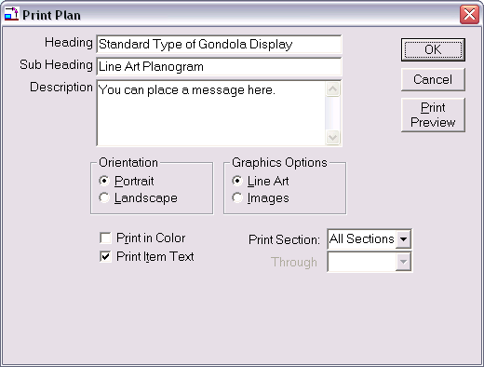
Figure 20 Print Planogram

Heading – Enter an optional heading for the planogram that will print centered at the top of the page margin in large type. This heading will become the default heading for all reports printed for this planogram, eliminating the need to re-enter it on other reports.
Sub-Heading – By default, the name of the report will appear in the sub-heading field but can be changed by the user. The sub-heading will print in slightly smaller type, centered below the heading.
Description – You may enter an optional description that will print at the bottom of the page in the footer. The report footer also contain the current date, the name of the report, the name of the planogram file, and the version of Shelf Logic® used to create the planogram.
Print in Color - Deselect this option if you are using a black and white printer.
Print Text – By selecting this option, items will print on the planogram with Item Number, Item Name, and Key Number. Deselecting this option will print items with a Key Number only. The option you select will depend upon the individual planogram. Small items print better without text.

Graphic Options – Selecting the Line Art option will print the items as boxes and custom shapes (where applicable). Selecting the Images option will print the items as photographic images, provided that an image file was entered into the items database.
Printing the Planogram by Section
In the Print Planogram dialogue box, select all sections to print the entire planogram on a single sheet of paper. Select a starting and ending section to print only selected sections of the planogram a single sheet of paper. To print a single section per page, choose that section as the starting and ending section.
After selecting the appropriate options, click the OK Button to print, or the Cancel Button to cancel printing and return to the main Shelf Logic® screen.

Print Peg Holes
You can control whether or not background peg holes print on your final planogram by turning them on or off from the View Menu. If there is a checkmark in front of the Show Peg holes option, the peg holes will be visible on screen and will print on the planogram. Deselecting Show Peg holes will turn them off for both the screen and printed planogram.

Printing the Planogram as a Graphic Image
Menu: File/Save Plan as Image

After executing the above command, the following dialogue box will open. Heading, Sub Heading and Description are optional. Select from high-resolution image or low-resolution image, depending upon your needs. A high-resolution image will create a superior printout but creates a very large image file. A low-resolution file is more suitable for emailing and web pages, where the image will only be viewed on screen.
After clicking OK, a standard Save File dialogue box will open. Graphic files can be saved in several formats including .bmp, .jpg, .esp, and .tif.
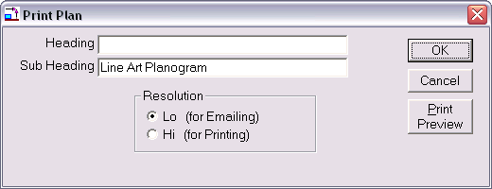
Figure 31 Create Image File

Section 11 – Reports

Generating and Printing Reports

Shelf Logic® Quik Plan has several useful reports that can be automatically generated from inside the program. In addition, plan files can be exported into Excel to create custom reports.
All standard reports are accessible from the Report Menu. Upon selecting a report from the menu, the Report dialogue box will open as shown below:

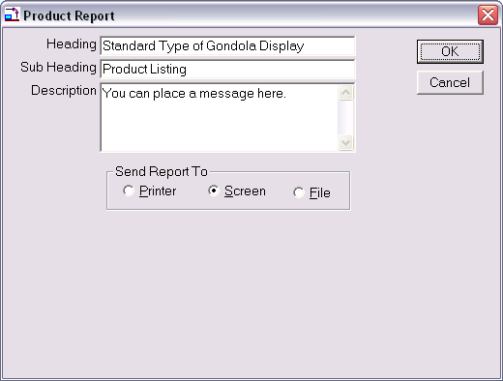
Figure 32 Report Dialogue Box
Reports displayed to screen now open in a separate window so that the plan and report can be viewed at the same time. The report can be printed or exported to a file directly from this window. The <Page Up> and <Page Down> keys are used to scroll from one page to another.
Heading – Enter an optional heading for the report. The heading will appear in large type, centered at the top of the page. This heading will become the default heading for all reports generated from this planogram.
Sub Heading – Enter an optional sub heading for the report. The sub heading will appear in slightly smaller type, centered below the heading.
Description – Enter an optional report description. The description will appear at the bottom of the report.
Send Report To –The report can be viewed on screen, sent to a printer, or printed to a file.
- When printing to the screen, the report will open in a separate window. Use the <Page Up> and <Page Down> keys to scroll through multiple pages
- When selecting the print to file option, enter a path and file name when prompted to do so. The report can be generated to a text or html file, which can be opened and customized in any word processing, spreadsheet, text or web editor application.

Standard Reports

Display Schematic Listing
This report lists all of the data needed for constructing the shelving.

Product Listing
This report lists all of the items on the planogram with details such as Item Number, Item Name, side number, side dimensions, number in stack, and hook size. This report is used for constructing the display.

Item File Detail
This report prints out the items database and all details.

Phone (845) 796-4242
info@shelflogic.com

