Shelf Logic® Pro
Version 10.2 Release .00
User’s Manual

October 1, 2003

© 1997- 2003 Logical Planning Systems, Ltd.
Shelf Logic® is a registered trademark of Logical Planning Systems™, Ltd.
22 Colony Drive, Holbrook NY 11741
All rights reserved.
Phone (631) 289-0055 • Fax (631) 475-9534

Table of Contents

Section 1 – Introduction 7
Welcome to Shelf Logic® Pro 7
Getting Help 7
About This User Manual 7
Online Help 8
Training 8
Technical Support 9
What Does Technical Support Cover? 9
Image Support 10
Shelf Logic® Web Site User Section 10
Section 2 – Installation 11
Installing Shelf Logic® Pro 11
System Requirements 10
Instructions for First Time Installations 11
Registering Shelf Logic® Pro 11
Upgrading From a Previous Version 12
Moving Shelf Logic® Pro 12
Reinstalling Shelf Logic® Pro 12
Getting Started 13
Starting Shelf Logic® Pro 13
Section 3 – Overview 14
Program Specifications 14
Capabilities 14
Plan Scaling 14
Screen Elements 14
Main Window 14
Button Bar 16
Tool Bar 18
How to Execute Commands 19
Menus 19
Hot Buttons 19
Shortcut Menus (Right Mouse Button) 19
Double-Clicking an Object 20
Drag and Drop 20
Keyboard Shortcuts 20
Reference List of Keyboard Shortcuts 21
List of Menus & Commands 22
File Menu 22
Edit Menu 22
View Menu 23
Shelf Menu 23
Item Menu 23
Tools Menu 23
Report Menu 24
Help Menu 24
Section 4 – Database Setup 25
Creating the Database 25
Changing Field Labels 25
Entering Items into the Database 26
Item Maintenance Form 26
Item Maintenance Field Chart 28
Tips for Creating an Effective Database 31
Working With Image Files 32
Image File Formats 32
Custom Shape Images 33
Three-Sided Image Support 33
Maintaining the Items Database 35
Editing the Item Maintenance Form 35
Saving Changes to the Items Database 35
Deleting an Item From the Database 35
Update From Database 36
Working With Multiple Databases 37
Creating a New Database 37
Opening an Existing Database 38
Using the Items Database 39
The Item Selection Window 39
Filtering the Database 40
Include Feature 41
Searching the Items Database 42
Section 5 – Creating a Display 44
Display Concepts 44
Shelf/Peg Display Setup 45
Pallet Rack Display Setup 47
Horizontal Slat Wall Display Setup 49
Vertical Slide Display Setup 51
Working with Shelves 53
Adding Shelves to a Display 53
Adding a Floating Shelf to Pegboard or Slat Wall 55
How Shelf Logic® Calculates Shelf Space 57
Locking Shelves 58
Show Shelf Numbers 58
Working With Items 59
The Items Selection Window 59
Display-By Fields 59
Photo Images 59
Adding Items to the Planogram 60
Placing Items on Shelves 60
Placing Items on Hooks 60
Nesting Items 61
Duplicating Items 62
Flipping Items 62
Grouping Items 63
Section 6 – Automatic Features 65
Automatic Placement Features 65
Next Available Location 65
Smart Shelf 65
Auto Center 67
Auto Stack Fill 67
Section 7 – Editing Features 68
Editing Display Setup 68
Editing a Shelf 68
Deleting Items and Shelves 68
Section 8 – Other Features 69
Alignment Features 69
Using Guidelines to Position Items 69
Displaying Guidelines 69
Snap To Feature 69
Grid Setup 70
Turning the Grid On and Off 71
Cut/Copy/Paste 71
Undo Feature 72
Redo 73
Finding Items on the Planogram 73
Plan Information 73
Version Information 74
Viewing Features 74
Customizing the Screen Display 74
Show Ruler 74
Show Button Bar 74
Show Tool Bar 74
Show Guidelines 74
Show Pegholes 75
Scale, Zoom and Scrolling Features 75
Section 9 – File Management 78
Saving Plans 78
Name and Save a New Plan 78
Opening an Existing Plan 79
Saving a Copy With a New Name 79
Closing a Plan 80
Deleting a Plan 80
Exiting Shelf Logic® Pro 80
Performing Backups 81
Automatic File Backup 81
Section 10 – Printing 82
Types of Printouts 82
Print Options 82
Printer Setup 82
Page Setup 83
Print Planogram 83
Section Headers and Footers 84
Print Peg Holes 85
Printing the Planogram as a Graphic Image 85
Printing the Planogram to a PRN File 86
Printing the Planogram to an Adobe Acrobat PDF File 87
Section 11 – Reports 88
Generating and Printing Reports 88
Standard Reports 89
Display Schematic Listing 89
Product Listing 89
Space Analysis Report 89
Financial Report 89
Item File Detail 90
Item File Summary 90
Creating Custom Reports 90
Export the Plan File to Excel 90
Custom Report Macros 90
Section 12 – Exporting & Importing 91
Exporting and Importing Files 91
Exporting and Importing a Database 92
Exporting the Item File from Shelf Logic® to Excel 92
Creating the Items Database in Excel 92
Database Fields Chart 93
Color Chart 94
Saving the Export File 95
Importing the .CSV File into Shelf Logic® 95
Database Import Checklist 96
Exporting Plans 96
Exporting the plan file to Excel 96

Table of Graphics
Figure 1 Main Window 15
Figure 2 Field Labels 26
Figure 3 Item Maintenance 27
Figure 4 Side 1/Front Figure 5 Side 2/Side Figure 6 Side 3/Top 34
Figure 7 Deleted UPC Code 36
Figure 8 Changed Item Dimensions 36
Figure 9 New Database 37
Figure 10 Existing Database 38
Figure 11 Item Selection Window 39
Figure 12 Database Filter Form 40
Figure 13 Database Search Form 43
Figure 14 Display Setup Shelf/Peg 45
Figure 15 Display Setup Pallet Rack 47
Figure 16 Display Setup Slat Wall 49
Figure 17 Display Setup Vertical Slide 51
Figure 18 Add Shelf 53
Figure 19 Floating Shelf Setup 55
Figure 20 Three Floating Shelves with 1 base shelf. 56
Figure 21 Peg item on hook and same peg item on shelf. 61
Figure 22 Nested Baskets 62
Figure 23 Drawing the Lasso 64
Figure 24 The Group Formed by the Above Lasso 64
Figure 25 Dragging Shelves with Smart Shelf On (left) and Off (right) 66
Figure 26 Stack Number 67
Figure 27 Snap To 69
Figure 28 Grid Setup 70
Figure 29 Find Item 73
Figure 30 Viewing Scale 75
Figure 31 Scroll Bar 76
Figure 32 Save Plan 78
Figure 33 File Open 79
Figure 34 Print Planogram 83
Figure 35 Section Headers & Footers 84
Figure 36 Create Image File 85
Figure 37 Report Dialogue Box 88
Figure 38 Color Chart 94

Section 1 – Introduction

Welcome to Shelf Logic® Pro
Shelf Logic® Pro is a simple to use yet powerful program specifically designed to create planograms for shelving, pegboard and slat wall merchandising displays. Automatic features such as Smart Shelf and Next Location make item placement as simple as clicking your mouse.

Your planograms can be created and printed using actual photographic images or line art representations that are scaled to the same dimensions of width, height and depth as the actual products. Statistical data is provided for the construction of the display, and for doing sophisticated space analysis.

Shelf Logic® Pro has several features that make it easy to incorporate your planograms into web pages, catalogues, documents and email.

Getting Help

About This User Manual
This manual provides detailed information on all of the features of Shelf Logic® Pro, as well as tips for creating and maintaining your database, image files, and merchandising display plans.

Like the program itself, this manual will keep growing and evolving in response to the needs of our users. Updates will be available for download from the Shelf Logic® web site user section. We welcome your comments on corrections or improvements that will help make this manual more useful. Please email to:

Help@ShelfLogic.com

This manual assumes that you have a basic working knowledge of Microsoft Windows®. If you are not familiar with Windows® terms such as dialogue boxes, mouse-clicks, menus, Windows Explorer, etc., consider reading Microsoft’s guide entitled “Getting Started with Microsoft Windows®“ or another suitable tutorial. A basic working knowledge of Windows® and its features is essential to effective use of any software program.
This manual assumes that you are using a standard right-handed mouse with the left button set as the primary button. When the manual refers to clicking and double clicking, it is always with the left mouse button, unless otherwise specified. If you are left-handed, you can switch the left and right mouse buttons through the Windows® Control Panel.

Throughout this manual you will see the following icon in the left margin to call attention to important procedures:
☑

Text that appears bold and italicized indicates a computer command that must be typed exactly as shown (but in normal type).

When referring to a specific key on the keyboard, the name of the key will appear in brackets, for example <enter> means press the enter key. A keyboard combination such as <Ctrl + S> means you hold down the Ctrl key while pressing the letter S, (or whichever letter applies to the specific command).

Instructions for executing menu commands are shown as menu name/command name:

File/Save As – first click on File Menu then select the Save As command.

Online Help
The Shelf Logic® Help file incorporates the latest features of a Windows Help System. Online Help can be accessed from inside Shelf Logic® Pro by clicking on the Help Menu. The online Help System provides step-by-step "How To" instructions, and in some cases refers the user to the appropriate section of the User Manual for more detailed information. If your operating system does not support the most current Help File System, contact Technical Support for assistance.

Training
A three-hour telephone-based training course consisting of two sessions is available for an additional fee. To purchase and schedule training, contact the main office at:

Phone (631) 654-8358

Reading through the manual prior to your training session, will significantly enhance your learning experience. The time spent learning Shelf Logic® Pro will pay off many times over in greater productivity, better quality planogram and increased sales.

Technical Support
Normal operating hours for the Technical Support Department are as follows:
Monday – Friday
10:00 AM - 4:00 PM, EST
Phone (631) 654-8358

Your purchase of Shelf Logic® Pro includes free telephone and email technical support. All questions regarding the operation of Shelf Logic® software should be sent to:
Help@ShelfLogic.com

Response time is usually within one business day. When contacting technical support you must include the following information. Failure to provide the necessary information will result in a delayed response.

- Company name and User ID number.
- User name and phone number.
- Shelf Logic® product and version number.
- Operating system and version number.
- Computer processor speed and amount of RAM.
- Detailed description of the problem that occurred including any error message.
- How many times the problem has occurred.
- What other programs (if any) were running when the problem occurred.

What Does Technical Support Cover?
The role of technical support is to assist the user with operating problems, provide clarification of printed or online documentation, answer common questions about getting started, and for gathering user feedback on their Shelf Logic® experience. Technical Support is not offered as an alternative to reading the User Manual or to provide extensive training.

The many features of Shelf Logic® Pro have been designed to make the job of planogramming simple and enjoyable. However, no matter how easy a software program might be, you can only use it to its fullest capability if you learn to use it properly.

With Shelf Logic® Pro, the learning process takes the intermediate computer user about three hours. Reading our User Manual with the program running is usually all it takes. If you do not take the time to do so, you will miss out on many of the time saving features and helpful tips we provide throughout this manual.

Image Support
The User Manual contains suggestions for preparing your images for use with Shelf Logic® Pro. Due to the vast number of graphic software programs currently in use, we cannot provide assistance with editing or converting your images. Please consult technical support for the graphic program you use.

We can provide assistance in creating your images on a fee for service basis. Contact the Sales Department for additional details.

Shelf Logic® Web Site User Section
You will need a User ID and password to gain access to the web site User Section. Your User ID and password can be found in the introduction letter that is shipped with your software. If you do not have your User ID and password, please contact Technical Support. Some of the features of this section are:

- Software Registration
- User Manual updates for download.
- Program updates for download.
- Tips and FAQ’s (frequently asked questions).

System Requirements
- PC compatible Windows 98, ME, NT, 2000, XP
- Pentium III Processor (or equivalent), 700 Mhz
- 96 MB of RAM (higher recommended)
- 16 MB Graphics Card
- 20 MB available hard disk space

Section 2 – Installation

Installing Shelf Logic® Pro

Instructions for First Time Installations
(See upgrading section below if you currently run Shelf Logic® Express or an earlier version of Shelf Logic® Pro.)

- Insert the Shelf Logic® Pro Pro CD into the CD ROM tray.
- From the Windows Start Menu, select the Run command.
- Click the Browse button, navigate to your CD ROM drive and select the file named ShelfLogic_PE_Install.exe. Click the Open button.
- Press <enter> or click OK.

The installation program will install Shelf Logic® Pro into a folder named C:\ShelfLogic_PE.
- A subfolder named Backup will be created for storing backup files.
- A subfolder named DataFile will be created for planogram and database files.
- A subfolder named Images will be created for storing photo image files.
- A subfolder named Samples, which contains a practice database and demo plan files.
- A Shelf Logic® Pro Program Group will be created on the Windows® Start Menu with icons for starting Shelf Logic, moving Shelf Logic®, registering Shelf Logic® and complete Uninstall.
- A desktop shortcut for Shelf Logic® Pro will also be created.

Registering Shelf Logic® Pro
After installing the program (but before running it for the first time) you will need to register your Shelf Logic® software and obtain a key code. You can register on our web site by going to the User Section of our web site at www.ShelfLogic.com.
You will need a User ID and password to gain access to the web site User Section. Your User ID and password can be found in the introduction letter that is shipped with your software.

Once you have accessed the User Section, click the Shelf Logic® Register icon on the Windows Start Menu/Programs. This will generate your registration number. You must have the registration window open through the entire process. If you close the registration box before entering the key code, the registration number becomes void and the key number will not work.

The key code you will be issued is only valid for one installation so you will need to obtain a new key code for each copy of Shelf Logic® Pro that you purchase.

If you need assistance in registering your software, please contact Technical Support.
☑
Note: Please refer to the section on Removing Shelf Logic® which contains important information about moving, reinstalling, and re-registering your Shelf Logic® software.

Upgrading From a Previous Version

If you are currently using Shelf Logic® you must contact Tech Support for assistance with your upgrade and conversion to Shelf Logic® Master Edition.

Moving Shelf Logic® Pro

Please follow these instructions carefully in case you need to move Shelf Logic® Pro to a different computer or reinstall at a later date:
- Copy the DataFile folder and Images folder to a removable medium (floppy disk, zip disk, tape or network drive) before running the remove program. You will need to transfer these files to the new installation.
- From the Windows Start Menu, select Shelf Logic® Pro/Move.
- Shelf Logic® Pro will be removed from you computer and a removal code will be displayed on your screen.
- **You must write down this removal code and store it in a safe place or send it directly to help@shelflogic.com. **
Note: You must have the removal code when you reinstall and reregister Shelf Logic® Pro. This removal code is valid for only one reinstall so you must have a new removal code each time the software is moved.
☑

Reinstalling Shelf Logic® Pro

- Reinstall Shelf Logic® Pro following the instructions at the beginning of this section.
- Copy your data files to C:\ShelfLogic_PE\DataFile.
- Copy your image files to C:\ ShelfLogic_PE\Images.
- Run Shelf Logic® Register according to the instructions above.
☑
You will need both the removal code and the new registration number when contacting Technical Support.

Getting Started

Starting Shelf Logic® Pro
Once installation is complete, you may begin using and learning Shelf Logic® Pro. From the Windows Start Menu, select Programs, then the Shelf Logic® Pro Program Group. Click the Shelf Logic® Pro icon to run the program, or double-click the Shelf Logic® Pro desktop icon.
Section 3 of this User Manual provides an overview of the program, the main screen elements and menu commands. Section 4 covers the Items Database, and Section 5 takes you through the process of creating your first planogram.
A practice database and plan files have been included for use during the learning process. To access the sample files:
- Click File/Open
- Double-click the ShelfLogic_PE folder.
- Double-click the Samples folder.
- Double-click one of the sample files. This will open a sample planogram and activate the sample database.

Note: The sample database will continue to be active until you close Shelf Logic® Pro or activate another database. When you are ready to begin entering items into the database, make sure that item.mdb is the active database file. If you are not sure how to do this, close Shelf Logic® Pro and reopen it again.
☑

Section 3 – Overview

Program Specifications

Capabilities
Number of items per database file: | Unlimited
Maximum faces on a plan: | 1000
Maximum Items stacked behind each other in a facing: | 255
Maximum shelves on a plan: | 250
Maximum plan width: | 50 Feet
Maximum plan height: | 50 Feet
Maximum number of databases: | Unlimited
Maximum number of databases per plan: | 1
Maximum Levels of Undo and Redo: | 10

Plan Scaling
Zoom Ratio: 1.5:1 to 63:1 (at 640x480 monitor resolution)
Scale Ratio: 5 1/4-feet/screen inch to 1 1/2-inches/screen inch
Viewing capacity: 45 x 27 feet to 3/4 x 1/14 feet (at 640x480 monitor resolution)
Item measurement accuracy to 1/16 inch

Screen Elements

Main Window
If you are running Shelf Logic® Pro while reading this manual, you will need to open a planogram to activate all of the menus and features.

Figure 1 Main Window
2. Button Bar
1. Menu Bar

4. Item Selection
Window
3. Plan Window

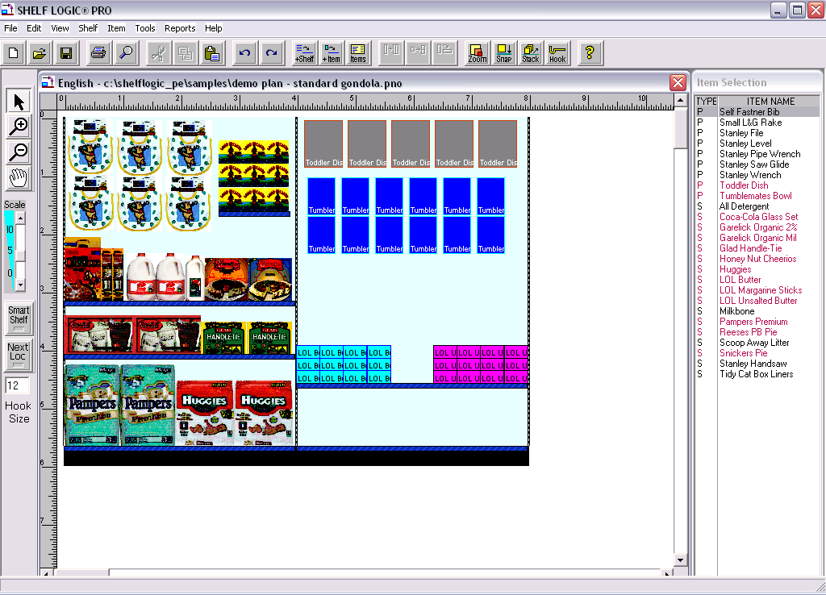
5. Rulers
- Tool
Bar
7. Status Bar
8. Scroll Bars

- Menu Bar – Contains all of the commands and features of Shelf Logic® Pro.
- Button Bar – Shortcuts to some of the most frequently used commands.
- Plan Window – This is where you will construct and edit your plan.
- Item Selection Window – Displays your Items database.
- Rulers – Located above and to the left of the Plan Window to aid in the positioning of items and shelves. One inch on the ruler bar equals one foot of actual display.
- Tool Bar – Contains several useful tools for viewing, creating and editing your plan.
- Status Bar – Displays information about the selected item or shelf. When a shelf is selected (highlighted) the Status Bar will display the shelf dimensions. When an item is selected (highlighted) the Status Bar will display the item details.
- Scroll Bars – Used to scroll through the Plan or Items Windows when the display is too large to be viewed in one screen.

Button Bar
 | New - Opens a new planogram. If another planogram is currently open, an alert box will remind you to save it.
 | Open - Opens an existing planogram file.
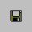 | Save - Saves the current planogram.
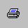 | Print – Opens the Print Dialogue Box.
 | Find - Finds items on the current planogram that match the selected item.
 | Cut - Cuts (removes) the selected item, shelf or group from the planogram.
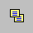 | Copy - Copies the selected item, shelf or group from the planogram.
 | Paste - Pastes a cut or copied object at the upper left corner of the Planogram Window.
 | Undo - Reverses the last action taken.
 | Redo - Restores the last Undo action.
 | Add Shelf - Opens the "Add Shelf" dialogue box.
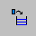 | Add Items – Positions the Items Window next to the Plan Window.
 | Items – Opens Item Maintenance.
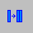 | Duplicate Right – Duplicates the selected item to the right.
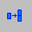 | Duplicate Up – Duplicates the selected item up.
 | Flip – Flips the selected item to one of 3 sides.
 | Zoom –Enlarge or decrease the view of the planogram.
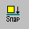 | Snap – Opens the Snap-To setup dialogue box.
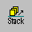 | Stack – Opens the Stack Setup dialogue box.
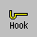 | Hook – Changes the peg hook size for an item on the planogram.
 | Help - Opens the Help System.

Tool Bar
1
2
3
4

5

6

7
8

1. Arrow – Toggles between the normal arrow pointer and the zoom pointers.
2. +Magnify – (Zoom In) Turns the pointer into a magnifying glass to enlarge the view of a specific item, shelf or section of the plan (changes the display only, not the actual plan). Each mouse click enlarges the view by one increment.
3. -Magnify – (Zoom Out) Turns the pointer into a magnifying glass to shrink the view and display more of the plan (changes the display only, not the actual plan). Each mouse click shrinks the view by one increment.
4. Grabber Tool – Turns the pointer into a hand and moves the plan up/down or right/left within the Plan Window (an alternative to Scroll Bars).
5. Scale Slider – Re-scales the size of the view in the Plan Window (an alternative method for zooming in and out).
6. Smart Shelf – Turns the Smart Shelf automatic features on and off.
- Next Loc – Turns the automatic placement feature on and off.
- Hook Size – Displays the default peg hook length.

Detailed information about all of the above features can be found in
Sections 5 through 8.

How to Execute Commands

The many features of Shelf Logic® Pro can be executed by using menus, keyboard shortcuts, button and tool bars, mouse clicks, or drag and drop. Before executing some commands, you must first select a shelf or item on which the command will be performed. Clicking the left mouse button on a shelf or item selects and highlights it in bright red.

Menus
There are two ways to execute commands from the menus:
- Using the mouse, click the menu name then click the command on the drop-down menu.
- Using the keyboard, hold down <Alt> and press the underlined letter in the menu name, then press the underlined letter in the command name.

Hot Buttons
The Hot Buttons located on the Button Bar are shortcuts to some of the more frequently used features. All of the Hot Button commands can also be found in the menus.

Shortcut Menus (Right Mouse Button)
In addition to the main menus, there are several shortcut menus that can be accessed by clicking the right mouse button over an object. These menus are object-sensitive, which means that the available options will be different depending upon the object you right-click on. We suggest experimenting with the right mouse button feature as much as possible. Once familiar with the different menus, you will find them to be considerable step-savers.

- Right clicking over a shelf will select the shelf and open a Shortcut Menu of commands relating to shelf arrangement.
- Right clicking over the plan area will open a Shortcut Menu of commands relating to display setup.
- Right clicking over an item in the Item Selection Window will select it and open a Shortcut Menu of commands relating to item maintenance.
- Right clicking over an item in the Plan Window selects it and opens a Shortcut Menu relating to item placement in the plan.

Double-Clicking an Object
Double-clicking an object in the plan window, such as a shelf or item, opens a maintenance menu that allows you to change the shelf dimensions or update the item in the database. Double-clicking the plan area opens the Display Setup dialogue box. Double-clicking an item in the Item Selection Window places the item on the plan.

Drag and Drop
Items can be dragged from the Item Selection Window and dropped onto the plan. To drag an item, select it from the Item Selection Window and hold down the left mouse button as you move the mouse. Release the mouse button to place the item on the plan.

When dragging and dropping an item, the Smart Shelf feature and Snap-To features still apply if turned on, but Next Available Location has no effect.

Keyboard Shortcuts
Some frequently used commands can be executed directly from the keyboard by holding down <Ctrl> or <Alt> and pressing a corresponding letter. If a particular command has a Keyboard Shortcut, it will appear on the menu next to the command name as follows: <Ctrl + letter>.

Reference List of Keyboard Shortcuts

Add Items to Database | <Ctrl +I>
Add Item to Planogram | <Ctrl + A>
Item Maintenance | <Ctrl + M>
File/Save | <Ctrl + S>
Open Existing Plan | <Ctrl + O>
Show Guidelines/Turn off Guidelines | <Ctrl + G>
Show Peg Holes/Turn Off Peg Holes | <Ctrl + H>
Show Photos/Turn Off Photos | <Ctrl + T>
Show By Quantity Sold | <Ctrl + Q>
Display Setup | <Ctrl + D>
Undo | <Ctrl + Z>
Redo | <Ctrl + R>
Cut | <Ctrl + X>
Copy | <Ctrl + C>
Paste | <Ctrl + V>
Find (Items on Planogram) | <Ctrl + F>
Zoom In | F8
Zoom Out | F7
Grabber Tool | <Shift> + Drag Mouse
Print Planogram | <Ctrl + P>
Scroll Forward through Item Maintenance | <Alt + D>
Scroll Backward through Item Maintenance | <Alt + B>
Exit Shelf Logic® | <Alt + F4>
Copy Selected Area | <Ctrl + Drag>

List of Menus & Commands

File Menu
New – Opens a new plan.
Open – Opens an existing plan.
Close – Closes a plan and clears the Plan Window.
Delete – Permanently deletes a plan from your hard drive.
Save – Saves the current plan.
Save As – Saves a copy of the current plan in a new file with a new name.
Save Plan as Image – Exports the plan to a bitmap image file.
New Database – Creates a new database file for items.
Open Database – Closes the current items database and opens another one.
Unit of Measure − Toggles between English and Metric unit of measure.
Import – Imports data into the items database from other applications.
Export Item File – Export the items database for use with other applications.
Export Plan – Exports the plan data for use in other applications.
Page Setup – Set page margins for planogram printouts.
Printer Setup – Change printers and printer options, such as paper orientation.
Exit – Closes Shelf Logic® Pro.

Edit Menu
Undo – Reverses up to 10 operations.
Redo – Reverses the last Undo operation.
Delete – Removes one or more items or shelves from a plan.
Cut – Deletes an object and stores it in the clipboard for reuse.
Copy – Copies an object to the clipboard for reuse.
Paste – Places the clipboard contents in a new location.
Find – Finds and highlights matching items in a plan.
Copy Image to Clipboard – Copies the selected area of the plan to the Windows clipboard for pasting into another application.

View Menu
Show Grid – Turns Grid display on and off.
Show Ruler – Turns Ruler display on and off.
Show Button Bar– Turns Button Bar display on and off.
Show Tool Bar – Turns Tool Bar display on and off.
Show Guidelines – Turns display of guidelines on and off.
Show Pegholes – Turns display of pegholes on and off.
Show Shelf Numbers – Turns display of shelf number tags on and off.
Show Photos – Turns photo image display on and off.
Display Setup – Changes the plan configuration.
Grid Setup – Changes the type and number of grid lines.
Snap To Setup – Turn the Snap-to features on and off.
Scale – Changes the scale of the plan on the screen.
Zoom in – Enlarges the view of a section of the plan.
Zoom out – Shrinks the view to display more of the plan.
Preferences – Set defaults for some of the program features.
Change Field Labels – Rename optional database fields.
Info – Displays information about the current plan.

Shelf Menu
Add – Set shelf dimensions and adds one or more shelves to the plan.
Change – Changes shelf dimensions or placement of an existing shelf.
Lock Shelves – Prevents shelves from being moved with selected items.

Item Menu
Maintenance – Add items or change existing items in the Items database file.
Place – Adds an item onto the plan.
Change Hook Length – Edit peg hook length for an item already on the planogram.
Number in Stack – Define the number of items to be placed in a stack.
Flip – Turns an item onto one of 3 sides and displays the corresponding image.
Duplicate Up – Duplicates the highlighted item upwards.
Duplicate Right - Duplicates the highlighted item to the right.
Filter – Specify which items are displayed in the Items Window.
Filter Off – Turns off the current filter and displays the entire database in the Items Window.
Update from Database – Updates item details that have been modified since the plan was created.

Tools Menu
Arrow – Toggles between the normal arrow pointer and the Tool Bar pointers.
Magnify Up – (Zoom In) Turns the pointer into a magnifying glass to enlarge the view of an item, shelf or section of the plan (changes the display only, not the actual plan). Each mouse click enlarges the view by one increment.
Magnify Down – (Zoom Out) Turns the pointer into a magnifying glass to shrink the view and display more of the plan (changes the display only, not the actual plan). Each mouse click shrinks the view by one increment.
Grab – Turns the pointer into a hand and moves the plan up/down or right/left within the Plan Window (an alternative to Scroll Bars).
Smart Shelf – Turns the Smart Shelf automatic features on and off.
Next Available Location – Turns the automatic placement feature on and off. Item Key Numbering – Turns manual key numbering mode on and off..

Report Menu
Print Planogram – Set print options for planograms.
Print Shelving Schematic – Set print options schematic printout.
Set Section Headers & Footers – Set headers and footers for planogram printouts.
Schematic Listing – Print or display information for constructing the actual shelving.
Product Listing – Print of display list of items on the display, quantities and placement.
Space Analysis Report – Analyzes display space usage.
Financial Analysis Report – Analyzes display profitability.
Item File Detail – Detailed information about the Items database file.
Item File Summary – Item file listing can be used as an aid to product selection.

Help Menu
Contents – Opens the Help system.
About – Shelf Logic® version and release information.

Section 4 – Database Setup

Creating the Database

Shelf Logic® Pro requires a minimal amount of initial setup, however, as with any new software, setup should be given careful consideration. Instructions for creating a database must be carefully followed. Data entry and product dimensions must be accurate. The quality of your final planogram is dependent upon an accurate, well-planned database.

Items can be entered into the database directly through Shelf Logic® Pro, or imported through an Excel spreadsheet. Which method you choose will depend upon the size of your database, whether your database already exists in another application, and your experience level with database concepts. In this section, items will be entered into the database through Shelf Logic® Pro. Importing a database is covered in Section 12. The Shelf Logic® database is ODBC compliant.

Note: Be sure that all plan files are closed and that only the main Shelf Logic® Pro application window is open (gray background). Many of the Hot Buttons and Menus will be inactive, however, the items database can still be accessed. If you previously had the sample files open during this working session, close Shelf Logic® Pro and reopen it to access the default items database.
☑

Customizing Your Database
The following database features can be customized, making the Shelf Logic® Pro database extremely flexible:

- Set the default database to a Shelf Logic® database in any folder on any drive.
- Change any optional field label so that any data can be entered and labeled correctly.
- Three user-defined fields that can be used for any additional data you wish to include in the database.

The Default Items Database
View Menu: Preferences

The default database is the database that automatically opens when you start Shelf Logic® Pro. The default is preset to C:\Shelflogic_PE\datafile\item.mdb, but you can create more database files and make any one of them the default.

Note: You must close and restart Shelf Logic® for the new default database to take effect.
☑
When you open an existing plan, the database used to create that plan will also open and become the new default for the current work session. If you are not sure which database is currently active, click the Items button on the button bar and check the window’s title bar. Upon exiting Shelf Logic® Pro, the default database reverts back to the default specified in Preferences.

Changing Field Labels
View Menu: Change Field Labels

Field labels can be customized for all optional fields and can be up to 9 characters long. If you have more than one database, changes to field labels effect all of them.

Note: Although you can change the UPC Code field, it is not an option field and entry of a unique number is required. Use caution when changing the UPC Code field label.

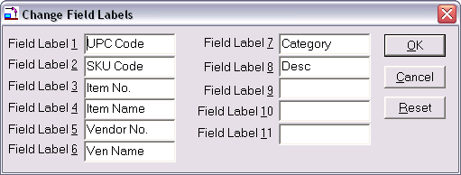
Figure 2 Field Labels

Entering Items into the Database

Item Maintenance Form
Hot Button: Items
Items Menu: Maintenance
Keyboard Shortcut: <Ctrl + I>

When you execute one of the above commands, the Item Maintenance form will open as shown below. The name and location of the active database file will appear on the title bar of the form—double check that you are using the correct database.

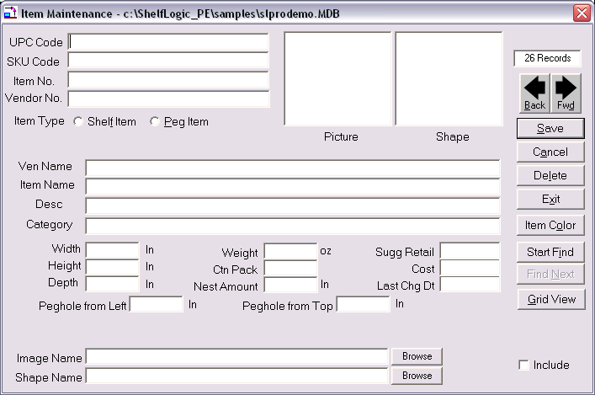
Figure 3 Item Maintenance

Each line in the form is called a field:
- use <Tab> to move forward one field,
- use <Shift +Tab> to move backward one field,
- or click the mouse inside the field to select it.

The UPC Code is the key field of the database and should always be entered first. If an item has already been entered using this UPC Code, the item details will fill the Item Maintenance form. The UPC Code must be unique for each item—duplicates are not allowed.

Some fields are required entries and some fields require data in a specific format. Each field has a maximum allowable number of characters. If a field is user-defined, that means numbers or letters are acceptable. Refer to the Item Maintenance chart below.

While your database is still in the planning stage, we suggest creating a practice planogram and printing out a sample of each report so you can see the effects of any empty or user-defined fields.

The following chart details the type of data to be entered when creating your database in Shelf Logic® Pro:

Item Maintenance Field Chart
Field Name  (**Can Edit Field Label) | Data Type | Maximum Characters | Description
**UPC Code | Required  unique  alphanumeric entry | 25 | The industry standard Universal Product Code. This field is the primary (key) field, which Shelf Logic® Pro uses to organize and locate items. It must be a unique number for each item—no duplicates are allowed.
**SKU Code | Optional  user-defined | 25 | The manufacturer's identification code for the particular item.
**Item No. | Optional  user-defined | 25 | Although this is an optional field, leaving it empty may have significant impact on your final results.
**Vendor No. | Optional  User-defined | 25 | Code or number to identify the vendor that supplies this item.
Item Type | Required  select from drop-down menu | Shelf Item  or  Peg Item | A Shelf Item is an object that can only be placed on a shelf. Placing a shelf item in a pegboard area will generate a warning message. A Peg Item can be placed on a shelf or hung from a hook.
Picture | Graphic | N/A | This field will automatically display the image associated with this item.
Shape | Graphic | N/A | This field will automatically display the custom shape associated with this item.
**Ven Name | Optional  User-defined | 50 | The full name of the vendor that supplies this item.
**Item Name | Optional  user-defined | 50 | Although this is an optional field, leaving it empty may have significant impact on your final results.

Field Name  (**Can Edit Field Label) | Data Type | Maximum Characters | Description
**Desc | Optional  User-defined | 50 | A detailed description of the item.
**Category | Optional  User-defined | 50 | This field can be used to organize items by groups of related products for database filtering. Some reports are sorted by category.
Width | Required  Numeric | 12 | The width of the item (left to right) in inches. Enter whole numbers or decimals (1, 1.25, 1.5). Do not enter fractions.
Height | Required  Numeric | 12 | The height of the item (top to bottom) in inches. Enter whole numbers or decimals (1, 1.25, 1.5). Do not enter fractions.
Depth | Required  Numeric | 12 | The depth of the item (front to back) in inches. Enter whole numbers or decimals (1, 1.25, 1.5). Do not enter fractions.
Weight | Optional  Numeric | 12 | The weight of a single item in ounces.
Ctn Pack | Optional  Numeric | 4 | The quantity of items packed into a single shipping carton.
Nest Amount | Optional  Numeric | 12 | The height in inches of the portion that shows when this item is stacked one inside the other.
Sugg Retail | Optional  Numeric | 12 | Enter the suggested retail price of the item in dollars. This field is used to calculate profit margins. Do not enter dollar signs.
Cost | Optional  Numeric | 12 | Enter the wholesale price of the item. This field is used to calculate profit margins. Do not enter dollar signs.
Last Chg Dt | N/A | N/A | No entry is made by the user. This field is controlled by Shelf Logic® and will automatically display the date of the last change to this item.

Field Name  (**Can Edit Field Label) | Data Type | Maximum Characters | Description
Peg Hole From Left | Required for Peg Items –  Numeric | 10 | This field is only available when the Peg Item Type is selected. Enter the distance from the left edge of the package to the center of the peg hole. Enter whole numbers or decimals (i.e. 0.25, 0.5, 0.75, 1). Do not enter fractions.
Peg Hole From Top | Required for Peg Items –  Numeric | 10 | This field is only available when the Peg Item Type is selected. Enter the distance from the top edge of the package to the center of the peg hole. Enter whole numbers or decimals (i.e. 0.25, 0.5, 0.75, 1). Do not enter fractions.
Image File | Optional | N/A | Enter the path (location) and filename of the image file to be associated with this item. Clicking the browse button will allow you to select the file from the contents of your computer.
Shape File | Optional | N/A | Enter the path (location) and filename of the shape image file to be associated with this item. Clicking the browse button will allow you to select the file from the contents of your computer.

Record Counter – Located at the upper right corner of the Item Maintenance form, the record counter indicates the total number of records in the database.

Forward & Back Buttons – Used to scroll through the contents of the Items Database. This is an alternative to searching when you have a small database, and an alternative to the “Save” button to edit a record and continue scrolling.

Save Button - Once the required data has been entered, click the Save button (or use the keyboard shortcut of <Alt + S>). After clicking the Save Button, the Item Maintenance form will clear so that another item can be entered.
Cancel Button– Clears the screen without saving changes.

Delete – Deletes the current record from the Items Database.

Exit –Closes the Item Maintenance screen and returns to the main Shelf Logic®Pro screen.

Item Colors - Click the Item Color Button to select a color scheme and pattern that will print in line art printouts and display on screen when photo images are turned off. Each item can have its own outline color, fill color, and pattern. If no color scheme is selected, a default of white with black outline will be used.

Start Find & Find Next –Searches the Items Database for specific items.

Grid View- when selected, shows the full database in a spreadsheet format from within the item maintenance window .

Include -This check box is used to include an item in a database filter when the item does not meet the criteria of the current filter. It should be left deselected (no check) during setup.

Tips for Creating an Effective Database
It is important to put some thought and planning into the initial setup of your database in order to achieve the best possible results. Following are some points to consider during the setup phase.

1. Enter a few test items and create some practice planograms.
- Print out the practice planogram and a sample of each report on the Report Menu.
- If you have left any fields empty, note the effect on reports, the Item Selection Window, the Plan Window, and planogram printouts.
- When entering your item dimensions, use the side most likely to face the front of the shelf. Although you can use the Flip Item feature to change the facing on your planogram, the dimensions entered into the database should be the ones most often used.
- We suggest color-coding items by category. This method helps organize your planogram and produces an attractive line art printout.
- When you start Shelf Logic® Pro, the default database will automatically open. You can create as many databases as you like using different file names; however, you can only use one database per plan. If you do create other databases, always make sure you know which one is currently active.
- Some changes to the Shelf Logic® database can have detrimental effects on existing plans. Never move or rename a database after it has been used to create any plans. Items deleted from the database will also be deleted from existing plans.
- Do you need more than one database?
There are several features in Shelf Logic® Pro that make it easy to work with a large database, and in most cases will eliminate the need to have more than one. There is no limit on the number of items in a Pro database; however, the maximum number of items in an Excel database is 65,536.
- Should you create your database in Shelf Logic® Pro or Excel?
If you are starting from scratch and your database is small, entering items directly into the Item Maintenance form is a simple process. If your database is large, using Excel is more efficient. If your database already exists in another database program, you will need to use Excel to prepare the database for import into Shelf Logic® Pro. You should be an intermediate level Excel user and be familiar with basic database concepts before attempting to import a database.

Working With Image Files
In order to use photographic images in your planograms, all you have to do is enter the item’s image file name and location in the Items database. Once entered, you should not move or rename image files and folders or you may have to recreate these links. Image files can be stored on any drive and in any folder, however, we recommend storing them in the Images subfolder created during installation of Shelf Logic® Pro.

Image File Formats
Shelf Logic® Pro supports both bitmap and JPEG image file formats.
A bitmap is a graphic image saved in the standard Windows graphic file format. Bitmaps are accepted by all Windows applications and generally produce the best quality photographic printouts, but bitmap files can be very large.

A JPEG file is another graphic image format commonly used for web pages, electronic transfer (email), and printed documents. JPEG files are smaller, transfer more quickly, and require less storage space.

You will achieve the best print quality with original images created in either bitmap or JPEG formats. Converting images from one format to another can cause a loss of detail and print quality.

If you are going to use photographic images or custom shapes with your plans, we suggest that you have access to a graphics software program that can perform the following functions:

- Convert files from other formats to bitmaps or JPEG’s if necessary.
- Resize or resample color images – Shelf Logic® Pro will automatically scale the bitmap image to the proper size for the planogram, however, if the image is too large or too small, print quality may be affected. The recommended size is approximately 100 to 400 pixels height or width, with the second dimension proportionate to the first.
- Cropping – the photograph should be taken straight on and never at an angle. Crop as close as possible to the edges of the actual item, removing as much excess background as possible.
- Change background color – since the printed planogram background is white, the graphic image background should also be white.
- Drawing tools for creating shapes.

Custom Shape Images
Custom shapes (irregularly shaped items that have a lot of excess background) can be overlapped on the planogram. This makes it possible to position items without the wasted excess background space. To display a custom shape, create the shape using any graphic imaging software. Save the image file as a .bmp or .jpg, and enter the file name and location in the Shape Name field.

The image shown below left was created in Paint Shop Pro, using an image size of 100 by 144 pixels. The image below right shows three overlapping facings of the same image on a display.

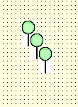
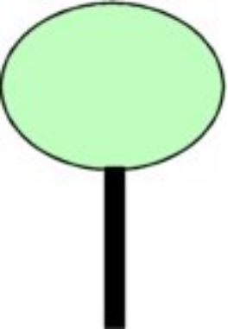

Three-Sided Image Support
Shelf Logic® Pro supports industry standard 3-sided images. These images must be in JPEG format and renamed with a .1 .2 or .3 extension. Only the image named .1 is entered into the image file field but all three images must be in the same folder. When the Flip Item feature is used, Shelf Logic® Pro will automatically use the item image with the corresponding side number. When an item is flipped to side 2, imagefile.2 will be used; and when flipped to side 3, imagefile.3 will be used.




Figure 4 Side 1/Front Figure 5 Side 2/Side Figure 6 Side 3/Top

Maintaining the Items Database

Editing the Item Maintenance Form
Menu: Item/Maintenance
Hot Button: Items

Executing one of the above commands will open an empty Item Maintenance screen to enter a new item or edit an existing one. Locate the item you wish to edit using one of the following methods:

- Select the item on the planogram, right-click and select Edit Item.
- Double-click the item on the planogram.
- Locate the item in the Items Window, right-click and select Edit Item.
- Open Item Maintenance and search the database for the item.

Saving Changes to the Items Database
After making changes to an existing item click the Save button to save the changes and clear the Item Maintenance form; or, click the right or left scroll button to save the new record and proceed to the next record. Once an existing item has been edited, Shelf Logic® Pro will automatically insert the current date in the Last Change Date field.

Editing the item’s UPC code will create a duplicate item with a new UPC code. The original item will remain unchanged.

Deleting an Item From the Database
After locating the item in the database, click the Delete button. Deleting an item in this manner permanently erases the item from the database.

☑
Note: Certain changes to an existing database can have detrimental effects on plans previously created with that database.

Update From Database
Menu: Item/Update from database

When a plan file is opened, Shelf Logic® Pro automatically checks the database for possible changes in three areas:

- Does the item on the plan still exist in the current database?

- If the item has been deleted, a warning dialogue box will open listing the deleted UPC codes and deleted items on the plan will be marked with a large black X as shown below. This item cannot be updated and should be removed from the plan.

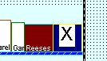

Figure 7 Deleted UPC Code

- Are the length, width and depth of the items on the plan the same as in the current database?

- If not, the item is marked with a large black exclamation point as shown below.

- Are the peg hole locations (left and top) the same as in the current database?

- If not, the item is marked with a large black exclamation point as shown below.

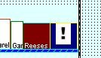

Figure 8 Changed Item Dimensions

The Update from Database command can be executed by selecting the above menu command, or by right-clicking the item on the plan. The selected item will be updated to reflect the new information in the database. The item's position may then need to be adjusted manually.

Working With Multiple Databases
Shelf Logic® Pro has the ability to create multiple item database files, however, you can only use one Item Database per plan. The default item database file is named Item.mdb (unless you have changed it) and is located in the DataFile subfolder.
Each time you start Shelf Logic® Pro, the default database is automatically opened. To use a database other than Item.mdb, you must first create and activate the new database file as described below. Once a database is used to create a plan, it becomes permanently associated with that plan file and will automatically open each time the plan file is opened.

Creating a New Database
Menu: File/New Database
Close any open plans. Upon executing the above command, the Open Database dialogue box will open as shown below:
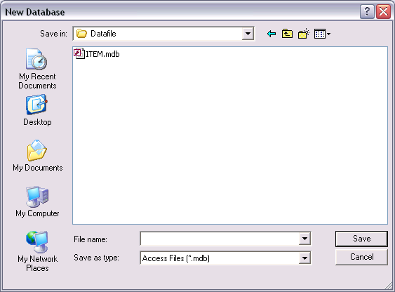
Figure 9 New Database
Enter a name for the new database and click OK. The new database will become the active database until you select another one or close and restart Shelf Logic® Pro. The Item Window will appear empty until items are entered into the new database.

Opening an Existing Database
Menu: File/Open Database
Close any open plans. Upon executing the above command, the Open Database dialogue box will open as shown below. Select a database file and click the Open Button. You can then create a new plan using the new items database.

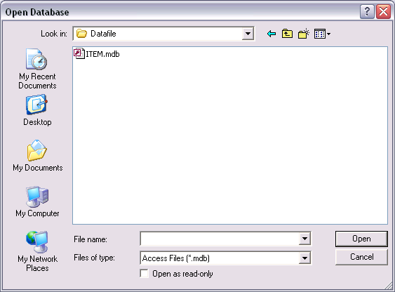
Figure 10 Existing Database

Using the Items Database

The Item Selection Window
When a new plan is created or an existing plan opened, the Item Selection Window will appear to the right of the Plan Window and display the active database. The Item Selection Window is automatically sized and positioned to fit within the main Shelf Logic® window.

Both the Plan Window and the Item Selection Window can be resized by dragging the window’s edge. Place the mouse pointer over the right edge of the Plan Window and the left edge of the Items Window. When the pointer becomes a double-headed arrow, drag to resize both windows for a perfect fit.

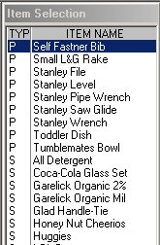

Figure 11 Item Selection Window

Items are listed in the Items Window in order of Item Type. Peg items are listed at the top and are preceded by the letter “P”; shelf items follow and are preceded by the letter “S”. The Item Number is the default display field, however, you can easily change the display field to UPC Code, SKU Code, Item Name or Description. To change the default Item display field:

- Place the mouse pointer inside the Items Window and right-click.
- Select the desired display field from the menu.

When you change the display-by field, your selection becomes the new default and will remain in effect until the next time you change it. The display-by field can also be set in Preferences. The selected display-by field and item number print on line art planograms.

To locate an item in the Item Window, click the mouse inside the window and type the first letter or number of the item. The curser (highlighted bar) will jump to the beginning of that section; or use the scroll bars to scroll through the list. When working with a large database the Filter Feature (see below) can be used to restrict the items that appear in the Item Selection Window for easier selection.

Once an item has been added to a planogram, the text color for that item will turn red, indicating that the item has already been selected. Removing that item from the planogram will restore the text color to black.

Filtering the Database
Menu: Item/Filter
Item/Filter Off
Executing the above Filter command will open the Create Filter dialogue box as shown below:
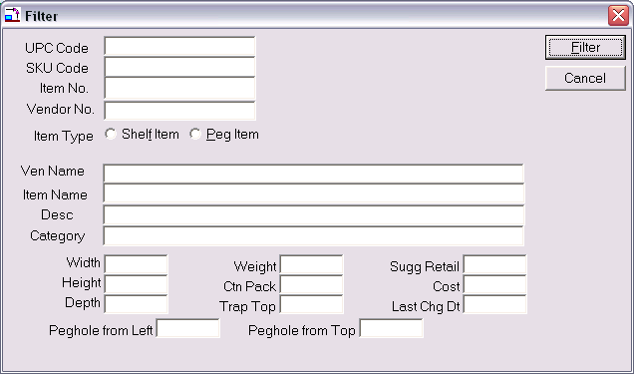
Figure 12 Database Filter Form
Filtering allows the user to select which items are displayed in the Items Window and in Item Maintenance. Filters can be turned on, off or changed at any time during a working session. To filter the database, you enter matching criteria in any field or fields of the filter form.
An "equal to" search is performed, which means that only items that are an exact match to the criteria entered will be included in the Item Window. You can increase the flexibility of filtering by using Boolean operators such as “greater than” and “less than”. Another way to expand a filter is by using the Include feature in Item Maintenance.
To create a filter:
- Click the Item Menu and select Filter.
- Fill in the data to be matched in one or more fields.
- Click the Filter Button.

To remove the filter and display the entire database:
- Click the Item Menu and select Filter Off.

Examples of Boolean Operators:
ABC* Starts with ABC
*ABC Ends with ABC
*ABC* Contains ABC
>=123 Greater than or equal to 123
=>123 Greater than or equal to 123
<=123 Less than or equal to 123
=<123 Less than or equal to 123
<>123 Not equal to 123
=123 Equal to 123
>123 Greater than 123
<123 Less than 123
If two (or more) fields in the filter form contain data, only those items that match both fields will be displayed in the filtered database.
Examples of Filters:
- Selecting Peg Items in the Items Type field will display only peg items in the Items Window. Selecting Shelf Items, will display only shelf items.
- An entry in the Category field of the filter form will display only the items that have the exact same entry in the Items Database Category field.
- An entry of <123400000000 in the UPC Code field will display items with UPC’s from 1 through 123399999999.
- An entry of >5.00 in the Suggested Retail field will display only those items with a suggested retail of over $5.00.
- An entry of Item Type = Peg Item, Category = Toys, and Suggested Retail <2.00 will display only peg items from the toy category with a suggested retail of $1.99 or less.

Include Feature
This feature is used to display items when they do not meet the current filter criteria.
To activate the Include feature:
- Turn off any existing filter.
- Click the Items Button on the Button Bar.
- Search the database for the items you want to include.
- Click the Include box at the lower right corner of the Item Maintenance form.
- Create a filter as described above.

Searching the Items Database
Hot Button: Items
Menu: Items/Maintenance
There are several ways to locate an item in the database. The method you use will depend upon the situation and personal preference. Upon executing the above command, the Item Maintenance screen will open.
Method #1: The forward and back arrows located just below the record counter will scroll through the database one record at a time.
Method #2: Enter the UPC code and press <tab>. The item details will appear on the Item Maintenance screen.
Method #3: Right-click an item in the Items Selection window or on an open plan.
Method #4: Click the Start Find button to open a search screen as shown below:

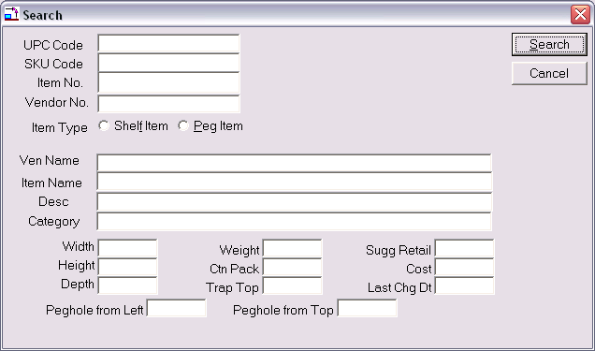
Figure 13 Database Search Form
The search parameters may be a word, several words, a number, or even just the first few characters or digits of any field. This is a "begins with" search, which means that a search parameter of "St" entered into the Vendor Name field will match any vendor name that begins with St. Case is ignored so that ST, St, and st, are all the same.
Enter search parameters in any field and click the Start Find button. The Item Maintenance Screen will open with the first match found. To continue the search, click the Find Next button until the message "No match found" is displayed.
To begin a new search, click the Start Find button again and repeat the above procedure.

Section 5 – Creating a Display

Display Concepts
This chapter will introduce the basic concepts of creating a planogram. Additional features of Shelf Logic® Pro are covered in Sections 6, 7 and 8.

The steps for creating a planogram are really very simple:

1. Define the display type and dimensions.
2. Add shelves to the display.
3. Add items to the display.

Your items are represented on the planogram by a scaled line art box, a custom shape, or a photographic image. Items can be placed anywhere on the planogram, however, warning messages will alert you when an item is not properly positioned, or if there is not enough space.

Automatic placement features such as Smart Shelf and Next Available Location make it easy to position or move items and shelves around the planogram. You can save various planogram scenarios and create reports to analyze the financial and market possibilities of each arrangement.

There are three display types in Shelf Logic® Pro:

- Shelf/Peg is used to create a shelving planogram, a pegboard planogram, a combination shelf/pegboard planogram, or pallet rack planogram.
- Slat wall is used to create a horizontal slat wall planogram.
- Vertical Slide is used to create a planogram where items are displayed on vertical fixtures such as waterfall hooks or literature racks.

Once the Display Setup is complete, the new planogram will appear in the Plan Window. The Items Database will open in the Items Selection Window. If you wish to use a different database, you must create and open that database before adding items to the planogram. The database used to create the planogram will be permanently associated with the plan file so that each time you open the plan, the associated database will open with it.

Shelf/Peg Display Setup
Hot Button: New Plan
Menu: File/New

After executing one of the above commands, the Display Setup dialogue box will open as shown below. A typical gondola display setup is shown:

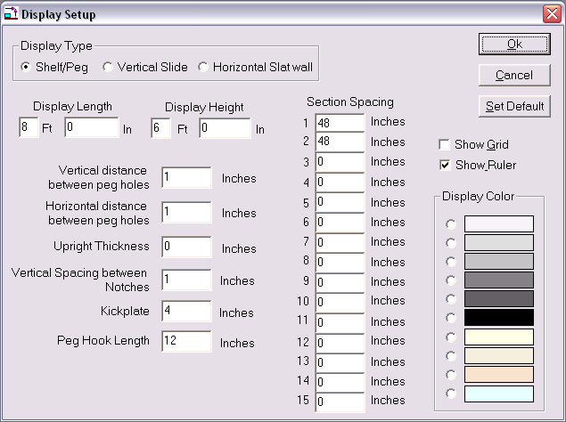

Figure 14 Display Setup Shelf/Peg
Type
Select Shelf/Peg to create a shelving display, a pegboard display, or a combination shelf and pegboard display.
Display Length & Display Height
These dimensions will determine the total area of your display. Measurements can be entered in feet, feet and inches, or all inches.
Vertical Distance & Horizontal Distance Between Peg Holes
These measurements determine the type of pegboard used for the display background. A minimum of .5” must be entered. Standard pegboard is one inch vertical by one inch horizontal. If you prefer not to have a pegboard background, you can turn off the peg holes later from the View Menu.
Upright Thickness
Vertical uprights are the framework onto which shelves are attached. For standard wall shelving or gondola shelving you may leave the thickness at zero. For heavy-duty pallet racks, the thickness of the uprights can impact available shelf space and must be accounted for within the total display size (see Pallet Rack Setup below).

Vertical Spacing Between Notches
This is the vertical distance between the slots on the vertical uprights into which the shelves will be attached. One inch is standard for most gondola or wall shelving. With one-inch slot positions, shelf height and shelf movement must be in one-inch increments. With two-inch slot positions, shelf height and shelf movement must be in two-inch increments.

Kickplate
This is the height of the kickplate or base unit. The kickplate appears as a solid black area at the bottom of the display. The top of the kickplate is the lowest possible position where a shelf may be placed, but it is not an actual shelf and cannot hold items.

Peg Hook Size
Enter the default peg hook size for the display.

Show Grid & Show Ruler
These features are used for item positioning and alignment. They can be turned on and off from Display Setup or from the View Menu. We suggest leaving the ruler on and the grid off for most displays.

Section Spacing
These measurements will determine how many sections your display will have and the length of each section. You can create up to 15 variable-sized sections per display. Enter the length of each section in inches. If your display has only one section, enter the total length in Section 1.
☑
Note: The total length of all the sections must equal the total display length.

Display Color
Select a background color for the display. This color is for on-screen viewing only and does not affect printed planograms. The printed planogram will have a white background to accommodate photographic images.

OK Button
Accepts the current setup, closes the Display Setup box, and opens the display in the Plan Window.
Cancel Button
Closes the Display Setup box without creating a new display or saving changes to an existing display.

Set Default
Clicking the Default button will save the current display setup. Each new planogram will begin with these dimensions, however, they can be changed as needed. Each time you click the Default button, the current setup will overwrite the previous one saved, but will not affect any planograms created previously.

Your basic display should now be visible in the Plan Window. Drag the Scale Slider Button on the Tool Bar to scale the view to your preference. When learning the program, it’s usually easier to position items and shelves in a larger scale.

Pallet Rack Display Setup
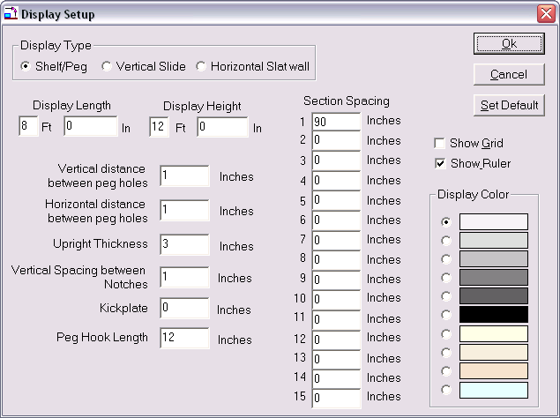

Figure 15 Display Setup Pallet Rack

Type
Select Shelf/Peg to create a pallet rack display.

Upright Thickness

A pallet rack display is created the same as a shelf/peg display with the exception of the upright thickness. Vertical uprights are the framework onto which shelves are attached. For standard wall shelving or gondola shelving you may leave the thickness at zero since shelves attach at the back of the display. For heavy-duty pallet racks, the thickness of the uprights can impact available shelf space and must be accounted for.

When the upright thickness is set to a number greater than zero, the combined measurement of the uprights must be subtracted from the section lengths. Failure to do so will cause the following warning message: “The display width is too small to fit the sections that were entered.”

Example:
- Display length = 8 feet
- Thickness of Vertical Uprights = 4 inches
- Number of sections in the display = 1
- Total number of uprights = 2
- Combined measurement of the 2 uprights = 8 inches
- Section spacing must be 88 inches.

Note: The total length of all sections, plus total upright thickness must equal the total display length.
☑

You are now ready to add shelves to a shelf/peg or pallet rack display.
For pegboard displays, you are ready to add items and/or floating shelves.

Horizontal Slat Wall Display Setup
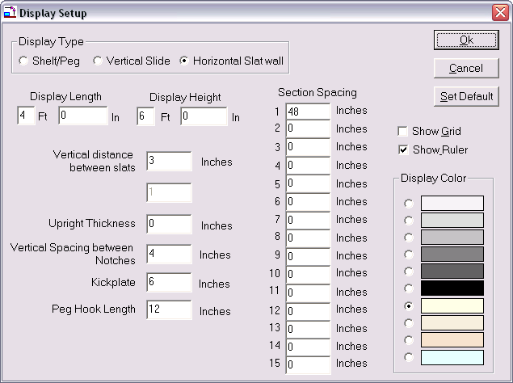
Figure 16 Display Setup Slat Wall
Type
Select Horizontal Slat wall.

Display Length & Display Height
These dimensions will determine the total area of your display. Measurements can be entered in feet, in feet and inches, or all inches.

Vertical Distance Between Slats
Measure the distance from the top of the channel to the bottom of the slat. Standard slat wall has a vertical distance of 3 inches.

Upright Thickness
Use the default setting of 0.

Vertical Spacing Between Notches
Use the default setting of 1.
Kickplate
This is an optional setting for slat wall that can be set to 0 if no base is needed.

Peg Hook Size
Enter the default peg hook size for the display.

Show Grid & Show Ruler
These features are used to aid with item positioning and alignment. They can be turned on and off from Display Setup or from the View Menu. We suggest leaving the ruler on and the grid off for most displays.

Section Spacing
If your slat wall display has only one section, enter the total length of the display in Section 1. The total length of all the sections, less space for uprights where applicable, should equal the total display length.

Display Color
Select a background color for the display. This color is for on-screen viewing only and does not affect printed planograms. The printed planogram will have a white background to accommodate photographic images.

OK Button
Accepts the current setup, closes the Display Setup box, and opens the display in the Plan Window.

Cancel Button
Closes the Display Setup box without creating a new display or saving changes to an existing display.

Set Default
Clicking the Default button will save the current display setup. Each new planogram will begin with these dimensions; however, they can be changed as needed. Each time you click the Default button, the current setup will overwrite the previous one saved, but will not affect any planograms created previously.

Your slat wall display should now be visible in the Plan Window. Drag the Slider Button on the Tool Bar to scale the view to your preference.

You are now ready to add shelves, floating shelves or items to the slat wall display.

Vertical Slide Display Setup
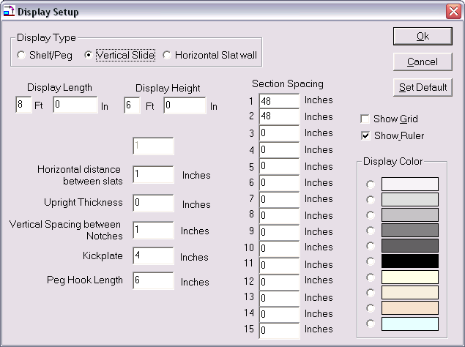
Figure 17 Display Setup Vertical Slide
Type
Select Vertical Slide.

Display Length & Display Height
These dimensions will determine the total area of your display. Measurements can be entered in feet, in feet and inches, or all inches.

Horizontal Distance Between Slats
Measure the distance from the left edge of the first vertical fixture to the left edge of the next vertical fixture.

Upright Thickness
Uprights are optional for Vertical Slide displays and can be set to zero.

Vertical Spacing Between Notches
This is the vertical distance between slots on the vertical uprights into which shelves or racks will be attached.

Kickplate
This is an optional setting for Vertical Slide.

Peg Hook Size
Enter the default peg hook size for the display.

Show Grid & Show Ruler
These features are used to aid with item positioning and alignment. The can be turned on and off from Display Setup or from the View Menu. We suggest leaving the ruler on and the grid off for most displays.

Section Spacing
If your vertical display has only one section, enter the total length of the display in Section 1. The total length of all the sections, less space for uprights where applicable, should equal the total display length.

Display Color
Select a background color for the display. This color is for on-screen viewing only and does not affect printed planograms. The printed planogram will have a white background to accommodate photographic images.

OK Button
Accepts the current setup, closes the Display Setup box, and opens the display in the Plan Window.

Cancel Button
Closes the Display Setup box without creating a new display or saving changes to an existing display.

Set Default
Clicking the Default button will save the current display setup. Each new planogram will begin with these dimensions; however, they can be changed as needed. Each time you click the Default button, the current setup will overwrite the previous one saved, but will not affect any planograms created previously.

Your vertical display should now be visible in the Plan Window. Drag the Slider Button on the Tool Bar to scale the view to your preference.

You can now begin floating shelves or items to the display.

Working with Shelves

Adding Shelves to a Display
Hot Button: +Shelf
Menu: Shelf/Add

After executing one of the above commands, the Add Shelf dialogue box will open as shown below. Shelves are always added to the display from the bottom up and can be added individually or in multiples. Shelves should never be longer than the section length defined in display setup.

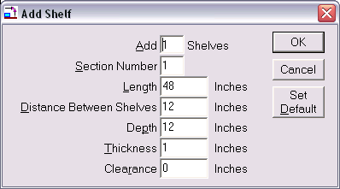

Figure 18 Add Shelf
Add__ Shelves
Enter the number of shelves to be added to the active section.

Section Number
Always defaults to the active section. The active section is the last section in which the mouse was clicked. You can change the default section number if necessary.

Length
This is the length of the shelf in inches from left to right. This measurement defaults to the length of the section as defined in Display Setup and cannot be changed.
☑
Note: If you need to add a shelf that is shorter or longer than the section length, the floating shelf feature should be used.

Distance Between Shelves
This is the shelf height, or the distance from the top surface of the current shelf to the bottom surface of the shelf above it. This is the area reserved for items and will appear as a shaded area on the screen.
☑
Note: The top shelf of each section will still have the specified shelf height reserved for items even though there is no shelf above it, as indicated by the shaded area.

Depth
The depth of the shelf in inches as measured from the front edge of the shelf to the back edge.

Thickness
Measurement made at the thickest point of the shelf.

Clearance
This is an optional setting and can be set to zero to maximize display space. Clearance reserves the specified amount of space at the top of the shelf. This space is left empty to allow a consumer to reach in and take an item off the shelf from the top rather than the front.

For example, if:

Shelf Height = 18 inches
Clearance = 3 inches
The tallest item that can be placed on this shelf = 15 inches

OK Button
Accepts the shelf dimensions, closes the Add Shelf dialogue box, and adds the shelf or shelves to the display in the Plan Window.

Cancel Button
Closes the Add Shelf dialogue box without adding shelves.

Default
Saves the current shelf dimensions as the default shelf setup.

The defined shelves should now appear on the display and are colored blue. To select a specific shelf, place the mouse pointer over the shelf and click the left mouse button. The selected shelf turns red.

The shaded area above the shelf is a visual aid for determining the space occupied by each shelf. Even though you will not see the pegboard background in this reserved area on your screen, you can still place peg hook items in the reserved area. When a peg item is placed with its bottom edge on a shelf, the item automatically becomes a shelf item as indicated on the Status Bar.

Adding a Floating Shelf to Pegboard or Slat Wall
A floating shelf is attached directly to pegboard or slat wall instead of to vertical uprights, and can be used to simulate many different pegboard or slat wall accessories. Floating shelves can be used with any display type and can be dragged to any position within the display.

The procedure for adding a floating shelf is identical to adding a regular shelf, except that the Section Number must be zero. A floating shelf can be any length since it does not attach to uprights.

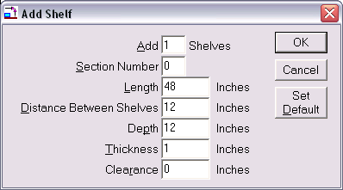
Figure 19 Floating Shelf Setup

The following display uses a full-sized base shelf and 3 floating shelves. Notice how the floating shelves attach directly to the pegboard instead of the standards.

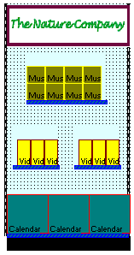

Figure 20 Three Floating Shelves with 1 base shelf.

How Shelf Logic® Calculates Shelf Space
To demonstrate how Shelf Logic® Pro calculates available space, let's consider the following example:
In Display Setup we have the following configuration:
Display Setup: 4' x 8'
Kickplate: 7"
In the Add Shelf box, we have the following configuration:
Length: 48"
Distance between shelves: 20"
Depth: 15"
Thickness: 1"
Clearance: 3"
Each shelf requires 24" in height (20” shelf height, 1” thickness, and 3” clearance) and 48" in length.
If we add one shelf to the display Shelf Logic® Pro calculates the following:
Display height 96"
less 7" kickplate
less 20" shelf height
less 1" shelf thickness
less 3" clearance
_________________
Remaining space
available for shelves 65"
Now add shelf #2:
Remaining space 65"
less 20" shelf height
less 1" shelf thickness
less 3" clearance
Remaining space 41"
If each additional shelf requires 24" of space, there is room to add only one more shelf. Or you can add one shelf with a 20” shelf height and one with a 13” shelf height.

Locking Shelves
Menu: Shelf/Lock Shelves
After building your shelving display, this feature locks the shelves in place and prevents you from accidentally moving a shelf along with an item or group of items when experimenting with different arrangements.

Show Shelf Numbers
Menu: View/Show Shelf Numbers

Selecting this option turns the display of shelf number tags on and off and is particularly useful when working with Smart Plan for Shelves.
☑
Note: If you have rearranged the shelf positions it is possible that the shelf numbers will not be in consecutive order on your planogram.

Working With Items

The Items Selection Window
The Items Window should appear to the right of the Plan Window. If it is not visible, click the +Items Button on the Button Bar. The Items Window is automatically sized and positioned to fit within the main Shelf Logic® window.

Both the Plan Window and the Items Selection Window can be resized by placing the mouse pointer over the right edge of the Plan Window and the left edge of the Items Window then dragging the double-arrow mouse pointer.

Items are listed in the Items Window in order of Item Type. Peg items are listed at the top and are preceded by the letter P, followed by shelf items.

Display-By Fields
The Item Number is the default display field, however, you can easily change the display field to UPC Code, SKU Code, Item Name or Description.

To change the default Item display field:

- Place the mouse pointer inside the Items Window and right-click.
- Select the desired display field from the menu.

Note: Unlike previous versions, the Display-By field now affects both the screen display and the planogram printout. When printing a planogram with line art and text, the Item Number field and the selected Display-By field will both appear on screen and on the printout.
☑

When you change the display-by field, your selection becomes the new default and will remain in effect until the next time you change it. The display-by field can also be set in Preferences.

Photo Images
View Menu: Show Photos
With the Photo Image feature turned on, you can build your planograms using actual photo images. For the purpose of speed and convenience, you can switch between line art mode and photo mode at any time by clicking on the above menu option.
- If there is no image associated with a particular item, a line art box will be substituted.
- If an item has a custom shape associated with it, the custom shape will appear on the planogram in line art mode only.
- If an item has both an image and custom shape, the shape will appear in line art mode and the image will appear in photo image mode.

Adding Items to the Planogram
Menu: Item/Place
Keyboard Shortcut: <Ctrl + A>
Mouse: Double-click the Item
Drag & Drop the Item

Items can be added using any of the above methods, however, double-clicking in the Item Window is usually the method of choice. Where the item appears on the planogram depends upon the following settings:

- Settings for automatic placement features (Smart Shelf and Next Loc).
- Whether a shelf or peg item is selected.
- Which shelf is currently selected.

In this section we will add items in manual mode. (Automatic placement features are covered in Section 6). With the automatic placement features turned off, (Next Loc and Smart Shelf buttons should be gray), the item will appear in the upper left corner of the Plan Window. The item will be highlighted in red, indicating that it is selected and ready to be positioned within the planogram by dragging it with the mouse. A deselected item appears in whatever color was assigned to it, or as a photographic image (if that feature is turned on).

Placing Items on Shelves
Both shelf item types and peg item types can be placed on shelves. If a shelf item is not properly positioned on the shelf, or does not fit in the selected position, a warning message will alert you. In manual mode these warning messages can be overridden and the item can be placed anywhere on the planogram. Use caution when overriding warnings since it is possible to place an item where no real space exists.

Placing Items on Hooks
Hot Button: Hook
Display Setup: Hook Size
Menu: Item/Change Hook Length

Only peg item types can be placed on hooks. Peg items are added in the same manner as shelf items. When the Next Location feature is turned off, peg items will appear at the upper left corner of the Plan Window and are then dragged into position. When positioning a peg item on the planogram, the item will automatically snap to the nearest available peg hole. You cannot place a peg item where there is no peg hole to accommodate the hook.

Turning Next Location on when adding peg items causes peg items to function the same as shelf items and will be added to the selected shelf. Placement must then conform to shelf dimensions rather than hook size.
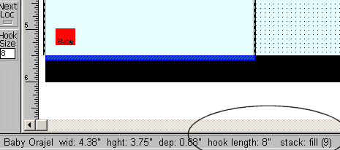

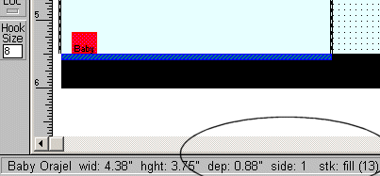

Figure 21 Peg item on hook and same peg item on shelf.

The default hook size is set in display setup and the size is displayed in the Hook Size box located on the Toolbar. You can change the default hook size in Display Setup or on the Toolbar at any time. You can also change the hook size for any item already on the plan, or for a group of items already on the plan.

Nesting Items
Items can be stacked one inside another, such as baskets, bowls or pots. A base item is placed on the shelf and then duplicated up using the Dup Up feature.

In the Nest Amount field of Item Maintenance, enter the height of the nested item that will show above the base item. This dimension is measured from the top edge of the item downward. For example, if you have a 6 inch high basket and you want the top inch of each basket to show above the base item, enter 1 in the Nest Amount field.

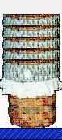
Figure 22 Nested Baskets

Duplicating Items
Hot Button: Dup Right
Dup Up
Menu: Item/Duplicate Right
Item/Duplicate Up

Once you have items on the planogram, you can duplicate them using one of three methods. With a little practice, you will discover which method is best suited to each situation.
Duplicate Up and Duplicate Right
The Duplicate Up Command will copy a selected item facing and stack the copy on top of the original. You can Duplicate Up repeatedly until you run out of space. The Duplicate Right command works the same way, but will place the copy to the right of the original. This is the easiest method for duplicating facings of items.

Flipping Items
Hot Button: Flip
Menu: Item/Flip
An item on the planogram can be flipped onto one of three sides. Executing one of the above commands will flip the selected item to the next side. The Status Bar will display the current side number and corresponding dimensions. If 3-sided image files are used, the appropriate image will be displayed for each side.
The Flip feature is useful for filling excess space at the end of a shelf. By shutting off Smart Shelf and Next Loc, you can manually add an item and flip it until it fits the available space.

Grouping Items
You can select a group of items, or items and shelves, by drawing a lasso (a dashed line) around the items. You only need to include a portion of an item in the lasso to include it in the grouping.
To draw a lasso around a group:
- Position the mouse pointer just outside one corner of the group.
- Hold down the left mouse button and drag the mouse so that the lasso forms around each item, or a part of each item. The mouse can be dragged up, down, left, right or diagonally.
- Release the mouse button.

When the mouse button is released, all of the items in the group will be selected (red). The group can then be moved, copied or deleted.
When including shelves in a grouping, at least one shelf in the group must contain an item--you cannot select empty shelves using this method. Use the Lock Shelves feature on the Shelf Menu to prevent shelves from accidentally being moved with groups of items.
In addition to moving groups of items, you can also use this feature to change peg hook size or stacking numbers for a group of items on the planogram. Select the group, select Items Menu/Change Hook Length, or Items Menu/Number in Stack and make the changes for all items in the group at the same time.
To de-select a group, click anywhere outside of the group.

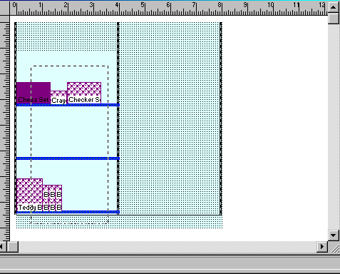
Figure 23 Drawing the Lasso
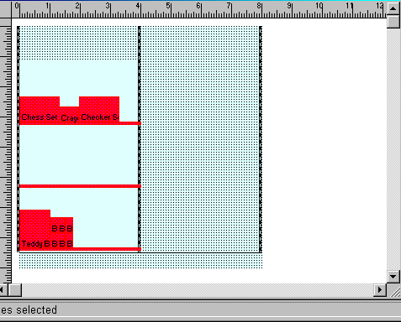
Figure 24 The Group Formed by the Above Lasso

Section 6 – Automatic Features

Automatic Placement Features

Next Available Location
The Next Available Location feature is turned on and off by clicking the Next Loc button located on the Toolbar, or by selecting it from the Tools Menu. The feature is active when the bottom of the button is red.
When placing a Shelf Item, the Next Available Location feature will automatically place items in the next available space on the selected shelf. Items are placed from left to right until all available space is filled. This is the easiest way to fill available shelf space with individual items.
When adding a Peg Item, the Next Available Location feature will place the item on the selected shelf as a shelf item. To add a Peg Item to the pegboard or slat wall area, this feature must be turned off.
When there is not enough space to place an item on the selected shelf, a warning message will alert you. To continue adding items you must select another item, select another shelf, or shut off the Next Available Location feature and add the item manually. The item will then appear at the top left corner of the Plan Window and can be dragged to the desired location. Use the Flip Feature to fit the item in the available space (see Section 5 – Flip Feature).

Smart Shelf
Smart Shelf is a group of automatic features that function together. Smart Shelf is turned on and off by clicking the Smart Shelf button on the Toolbar, or by selecting it from the Tools Menu. The Smart Shelf group of automatic features is active when the bottom of the button is red.
- Smart Shelf – checks the height, width and depth of each item added to the planogram to make sure it will fit on the selected shelf. A warning message will tell you which dimension is too large and the item will not be added. You can edit the shelf to accommodate the item or override Smart Shelf by shutting it off and adding the item manually. Exercise caution when adding items in manual mode since it is possible to place items where no real space exists.
- Auto Place – This is an extremely useful feature that properly positions items for you. When placing items next to each other, it can be difficult to line them up properly using your mouse. Items may appear jagged and uneven. With the Auto Place feature, all you need to do is drag an item close to the desired location and release the mouse button. Auto Place will align the item against the next closest item.
- Auto Move – This feature allows you to move a shelf together with any items already placed on that shelf. When Smart Shelf is turned off, the shelf will move but the items will remain in their original position.
- Auto Align –This feature allows you to drag a shelf from one location to another, or from one section to another. Smart Shelf will properly position the shelf between the vertical uprights.
- Auto Arrange – This feature allows you to move several shelves while still maintaining the height specified in the Add Shelf dialogue box. In the figure below, 3 shelves were added each with a height of 12”. With Smart Shelf on, shelf #2 was dragged upwards so that shelf #1 now has a height of 25”. As shelf #2 was dragged, everything above it moved with it. Shelves #2 and #3 were repositioned but still have the original 12” height. The second figure shows the effect of dragging a shelf with Smart Shelf turned off. Only shelf #2 moved—the items on it, as well as shelf #3 remained in their original place.

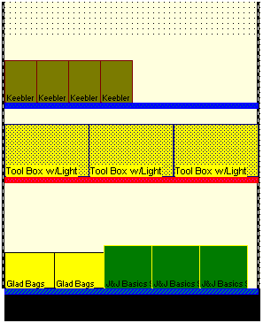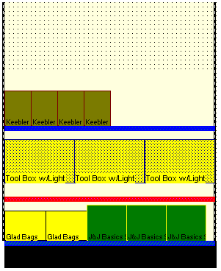
Figure 25 Dragging Shelves with Smart Shelf On (left) and Off (right)

Auto Center
This feature is always turned on and cannot be turned off. When adding or moving a shelf, auto center will position the shelf to the nearest available notch on the vertical uprights. When adding or moving peg items, auto center will position the item to the nearest available peg hole. This assures accuracy when building the physical display.

Auto Stack Fill
Hot Button: Stack
Menu: Item/Number in Stack
After executing the above command, the Stack Number dialogue box will open. When you add an item to a planogram, you are actually adding a facing of that item. A facing is a stack of items that fills a shelf or peg hook from the front edge to the back edge. By default, Auto Stack Fill is always on so that Shelf Logic® Pro will place as many items as will fit on the shelf or peg hook. If the peg hook length or shelf depth is changed, the quantity in the stack will automatically recalculate.
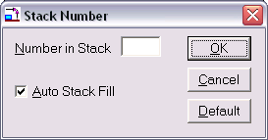

Figure 26 Stack Number
Number in stack – This will override Auto Stack Fill and specify a stack number for the selected item.
You can make this number the default for the rest of the plan by clicking the Default button. This will become the stack fill number for all items added to the planogram from this point forward. However, each time a new planogram is started, the default will return to Auto Stack Fill.
Auto Stack Fill – A check mark indicates that the feature is active.
OK Button – Saves changes to the Stack Fill dialogue box.
Cancel Button – Exits without saving the stacking information.
Default Button – Makes the entered number the default Stack Fill for all new items added to the planogram. It will remain the default until a new default is selected or a new plan is opened.

Section 7 – Editing Features

Editing Display Setup
The display dimensions of a planogram can be edited through the Display Setup dialogue box at any time. Double-click on an empty section of the planogram, or right-click and select Display Setup. Keep in mind that some changes to Display Setup may have significant impact on a planogram that is already under construction. We suggest saving your planogram before making any changes to the setup since you cannot use the Undo feature on changes to Display Setup. To restore the display to the previous configuration, close the file without saving changes and then re-open it.

Editing a Shelf
There are several ways to access the Change Shelf dialogue box:
- Double-click the shelf you wish to edit.
- Right-click over the shelf and select Change Shelf.
- With a shelf selected, click the Shelf Menu and select Change.
Shelf height can also be adjusted by dragging shelves up and down along the vertical uprights, or to a new section.

Deleting Items and Shelves
You can delete a single item or group of items, including shelves. Select the item or group and click the Cut button on the Button Bar, or right-click and select Delete from the menu. The deleted item is temporarily stored in the clipboard for reuse.
A shelf cannot be deleted if there are items on it. The items must first be moved, deleted, or grouped with the shelf.

Section 8 – Other Features

Alignment Features

Using Guidelines to Position Items
Shelf Logic® Pro lets you create up to 50 vertical and 50 horizontal guidelines to assist in the placement of items on the planogram. Using the Snap To Guideline feature, you can drag an item close to a guideline and it will automatically align against that guideline.
To create a guideline, place the mouse pointer over the horizontal or vertical ruler. When the pointer becomes a double-headed arrow, the guideline is dragged to the desired position on the planogram.
To move a guideline, place the mouse pointer on or near the guideline and drag to the new position. The mouse cursor will change to a double-headed arrow while you are moving the guideline.
To remove a guideline, drag it back onto the rulers or off the Plan Window.

Displaying Guidelines
Menu: View /Show Guidelines
Keyboard Shortcut: <Ctrl + G>
The Show Guidelines command turns the display of guidelines on and off. If you are using the Snap To Guidelines feature and the guidelines are hidden from view, the Snap To Guidelines feature is also temporarily turned off. Once the guidelines are again displayed, the Snap To Guidelines feature will be back in effect.

Snap To Feature
Hot Button: Snap
Menu: View/Snap to Setup
Executing one of the above commands will open the Snap To dialogue box as shown below:
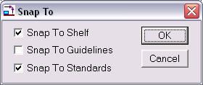
Figure 27 Snap To
The Snap To features make it possible to align items and shelves more accurately than dragging with the mouse. There are three Snap To options:
Snap to Shelf
When the Snap To Shelf feature is selected, dragging an item near the shelf will cause it to snap to and align with the shelf.
Snap to Guidelines
When the Snap To Guidelines feature is selected, dragging an item near a guideline will cause it to snap to and align with the guideline.
Snap to Standards
When the Snap To Standards feature is selected, an first item placed on the shelf will snap to and align evenly with the left vertical upright.

Grid Setup
Menu: View/Grid Setup
Shelf Logic® Pro can display grid lines or dots over the entire planogram to help position items. You can choose the style of grid and the vertical and horizontal distance between each grid line, however there is not Snap To feature. After executing the above command, the Grid Setup dialogue box will open as shown below:
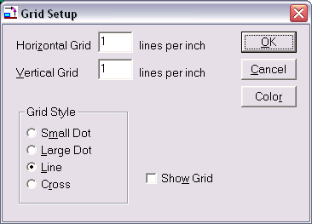
Figure 28 Grid Setup

Horizontal Grid lines per foot
This is the number of horizontal grid lines per foot of the display. An entry of 1 results in 1 grid line per foot. An entry of 12 results in 1 grid line per inch.
Vertical Grid lines per foot
This is the number of vertical grid lines per foot of the display. An entry of 1 results in 1 grid line per foot. An entry of 12 results in 1 grid line per inch.
Grid Style - Select from one of four grid types:
Small Dot – Displays a tiny dot at the intersection of each vertical and horizontal grid position.
Large Dot – Displays a larger dot at the intersection of each vertical and horizontal grid position.
Line – Displays a line for each vertical and horizontal grid position.
Cross – Displays a small cross at the intersection of each vertical and horizontal grid position.
Show Grid – Turns the grid display on and off.
OK Button – Accepts the grid setup.
Cancel Button – Exits without saving the grid setup.
Default Button – Makes the current grid setup the default setup for all plans where Show Grid is selected.
Color Button – The Color dialogue box will open. You can only select a foreground color since the grid has neither a pattern nor a background color.

Turning the Grid On and Off
Menu: View/Show Grid
This command toggles the display of the grid on and off. You can also turn the grid on or off from the Grid Setup and the Display Setup dialogue boxes.

Cut/Copy/Paste
Another way to duplicate items and/or shelves is by using the standard Windows Cut, Copy & Paste features. After cutting or copying an item, it can be pasted repeatedly into different locations on the planogram.
The Cut Command
Hot Button: Cut
Menu: Edit/Cut
Keyboard Shortcut: <Ctrl + X>
Upon executing one of the above commands, the selected shelf and/or items are removed from the original location and can be pasted into a new location. The Cut command is different from the Delete command in that Cut stores the objects for reuse and Delete removes the objects from the plan permanently.
The Copy Command
Hot Button: Copy
Menu: Edit/Copy
Keyboard Shortcut: <Ctrl + C>
The Copy command works the same way as the Cut command except that it copies the selected items/shelves, leaving the originals in place. Copies can then be pasted into a new area of the planogram.
The Paste Command
Hot Button: Paste
Menu: Edit/Paste
Keyboard Shortcut: <Ctrl + V>
The Paste command will place the contents the cut or copied items into the upper left corner of the Planogram Window. Pasted items will be highlighted so that you can move them into place. You can use the Paste command repeatedly.
Duplicate Copy
Another way to create duplicates is to select a shelf, an item, or a group, and hold down <Ctrl>, while dragging the selection to a new location on the planogram. As you drag, the original selection stays in place and the duplicate moves along with the mouse pointer to the new location. This method is best used when duplicating groups.
Copy Image to Clipboard
This command will copy the selected items and/or shelves to the Windows clipboard for pasting into other documents, such as MS Word or Excel.

Undo Feature
Hot Button: Undo
Menu: Edit/Undo
Keyboard Shortcut: <Ctrl + Z>
Each time one of the above commands is executed, your plan reverts back one action. You can click Undo up to 10 consecutive times. Actions that can be undone are:
- Moved shelves and items
- Deleted shelves and items
- Items placed on the planogram
- Updates from database (see Section 4)
- Cut and Paste

Redo
Hot Button: Redo
Menu: Edit/Redo
Keyboard Shortcut: <Ctrl+R>
Redo reverses the last Undo operation. You can Redo up to the last 10 Undo operations. If you delete a shelf, the Undo command would restore the deleted shelf. The Redo command would delete the shelf again. With Undo and Redo, you can go backward and forward through changes made to your planogram.

Finding Items on the Planogram
Hot Button: Find
Menu: Edit/Find
Keyboard Shortcut: <Ctrl + F>
The Find feature locates and highlights all matching items on a planogram. If an item on the planogram is selected, it is assumed that this is the item to match. Executing one of the above commands will locate and highlight items in the plan that matches the selection.
If no item is selected, the Find box will open as shown below. Enter a UPC Code, SKU Code, Item Code, Item Name or Category to locate matching items.
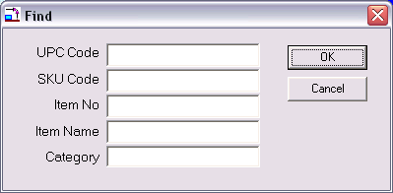

Figure 29 Find Item

Plan Information
Menu: View/Info
The View Info command displays the plan’s vital statistics such as the number of shelves and items, the name of the database used, and the version of Shelf Logic® Pro used to create the plan. This information is especially useful when reviewing older plans.

Version Information
Menu: Help/About
Upon executing the above command, a dialogue box will open and show which Shelf Logic® product and version is currently running.

Viewing Features
Shelf Logic® Pro has several features to customize the way the main screen is displayed. When working with large plans, turning off rulers, button bars, and tool bars will maximize the viewing space.
The following features can be turned on or off at any time during a work session from the View Menu:

Customizing the Screen Display

Show Ruler
Menu: View/Show Ruler
One inch on the ruler bar equals one foot of display space. When the rulers are turned off, you will have more working space in the Plan Window, however, you will not be able to create guidelines.

Show Button Bar
Menu: View/Show Button Bar
The Hot Buttons on the Button Bar are shortcuts to some of the more frequently used commands. Turning off the Button Bar provides more working screen space. Commands normally executed from the Button Bar can be executed from menus when the Button Bar is turned off.

Show Tool Bar
Menu: View/Show Tool Bar
Like the Button Bar, the Tool Bar also contains shortcuts to frequently used commands and features. These can be executed from menus when the Tool Bar is turned off.

Show Guidelines
Menu: View/Show Guidelines
It is sometimes helpful to turn off the guidelines for a clearer view of the planogram, however, the Snap-To Guidelines feature will not function when the guideline display is turned off.

Show Pegholes
Menu: View/Show Pegholes
When this is turned off, pegholes will not be visible on screen, but will still control the placement of items on the pegboard sections of the planogram. Turning off peghole display also turns them off on the planogram printout.

Scale, Zoom and Scrolling Features
There are several features that will change the scale of your plan as displayed on the screen. Scaling allows you to view more of the plan by scaling it down to a smaller size, or to enlarge a particular area for closer inspection. There are 10 possible scaling positions that range from 1½: 1 to 63:1.
The scaling feature is based upon a monitor resolution of 640x480, which is the recommended resolution when working in Shelf Logic® Pro. If you do not know how to change your monitor’s resolution in Windows, contact your System Administrator for assistance.
Because Scaling and Zooming are extremely useful tools, there are several alternative features available. Which feature you use will be based upon the particular situation and personal preference.

Changing the View Scale
Hot Button: Zoom
Menu: View/Scale
Tool Bar: Scale Scrollbar
Upon executing one of the above commands, the Viewing Scale dialogue box will open as shown below:
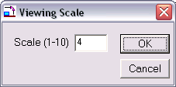
Figure 30 Viewing Scale
Enter a preset scale option by entering a number from 1 to 10. A scale of 1 makes the plan the smallest while 10 enlarges it to maximum size.

The Scale Scrollbar located on the Tool Bar at the left of the screen is an alternative method of setting the scale without using the dialogue box. Dragging the Slider Button will change the scale up or down to one of the 10 settings. For more exact scaling, clicking on the Scroll Arrows located above and below the scrollbar will increase or decrease the scale by an increment of 1 for each click.
Zoom In/Zoom Out
Menu: View/Zoom In
View/Zoom Out
Keyboard Shortcut: <F8 Key> Zooms In
<F7 Key> Zooms Out
The Zoom features work in much the same way as scaling. Zooming In will increase the scale in increments of 1 each time the command is executed. Zooming Out will decrease the scale in increments of 1 each time the command is executed.

Magnify Feature
Tool Bar: +Magnify Button
-Magnify Button
The Magnify Features allow you to select a specific item, shelf or section of the plan to zoom into or out of without the need for scrolling.
Clicking on one of the Magnify Buttons located on the Tool Bar will turn the mouse pointer into a Magnifying Glass. You can then click on the section of the plan you want to focus on. Each click will increase or decrease the scale factor by 1 increment. The Magnify feature will remain in effect until you deselect it by clicking on the pointer arrow at the top of the Tool Bar. This returns the mouse pointer to the standard arrow mode.

Scrolling Through the Plan
Depending upon the scale setting, you may not be able to view the entire plan in the Plan Window. There are two ways of scrolling to view areas of the plan not visible at the current scale.
Standard Scroll Bars
The horizontal and vertical Scroll Bars, located at the bottom and right edges of the Plan Window, are used to scroll through the Plan Window. The following figure demonstrates the various elements of a standard Scroll Bar:
Scroll Bar Slider
Scroll Bar

Scroll Buttons

Figure 31 Scroll Bar

Scroll Buttons – Each click will scroll left, right, up or down by 1 increment.
Scroll Bar Button – Indicates your relative position within the Plan Window. The Scroll Bar Button can be dragged with the mouse to scroll through the window.
Scroll Bar - Clicking on the vertical Scroll Bar above or below the Scroll Bar Button will scroll by a larger increment (or left/right on the horizontal Scroll Bar).
Grab Tool
Tool Bar: Hand Button
Keyboard Shortcut: <Shift Key>+ Drag Mouse
The Grab Tool is an alternative to using Scroll Bars. When the Grab tool is in effect, the mouse pointer changes to a hand. Position the hand inside the Plan Window and drag the screen up, down, left, or right to the desired view.
If the Tool Bar is not currently showing, you can activate the Grab Tool by holding down the <Shift Key> while dragging the mouse. Releasing the left mouse button returns the pointer to the standard arrow.

Section 9 – File Management

Saving Plans

Name and Save a New Plan
Hot Button: Save
Menu: File/Save
Keyboard Shortcut: <Ctrl + S>
We recommend naming and saving a new plan as soon as you have defined the layout, and also performing frequent saves throughout your work session. This will prevent the loss of your work should an operating problem or user error occur.
After executing one of the above commands, the standard Windows File Save dialogue box will open as shown below. You should accept the default save location in the ShelfLogic_PE/DataFile folder.

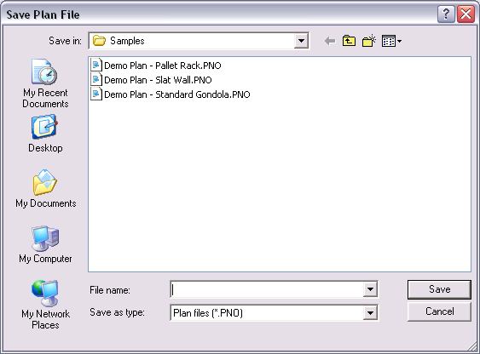
Figure 32 Save Plan

Enter a file name for the new plan. Long files names are acceptable. Do not include the period and 3-letter extension in your file name. The file extension of .PNO will automatically be added by Shelf Logic® Pro. Click the OK Button to save the file.

Opening an Existing Plan
Hot Button: Open
Menu: File/Open
Keyboard Shortcut: <Ctrl + O>
Once you have named and saved a plan, you can reopen it for editing at any time. After executing one of the above commands, the standard Windows Open File dialogue box will open as shown below. Select a plan from the list in the left window and click the OK Button to open it. The database used to create this plan will also open.
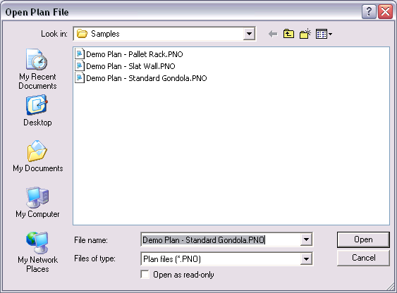
Figure 33 File Open

Saving a Copy With a New Name
Menu: File/Save As
After making changes to an existing planogram, you may want to save the changes in a new file, leaving the original planogram unchanged. This is a good way to make several different versions for comparisons. By saving your plan frequently under different names you can always revert to an earlier version.
After executing the above command, the standard Windows Save As dialogue box will open. Enter a new file name in the File Name box. Long file names are acceptable. Do not add the period and 3-letter extension. Click the OK button to save the file. The original file will close and the newly named file will become the active planogram file.

Closing a Plan
Hot Button: Windows Close Button
Menu: File/Close
You can close a plan using the above menu command, or by clicking on the standard Windows Close button located at the upper right corner of the Plan Window.
X
☑
Note: Be sure to select the Close button on the Plan Window and not the application window if you want to continue working in Shelf Logic® Pro.
The above command will close the current planogram file. If you have any unsaved changes, an alert box will open with the following message: “Changes have been made to your current plan. Do you wish to save it first?" Clicking on "Yes" will open the Save Plan dialogue box, where you can save the planogram under the current name or enter a new name. Clicking on "No" will close the plan without saving any changes.

Deleting a Plan
Menu: File/Delete
You must have the planogram file open before executing the above command. This command will completely remove the planogram file from your hard drive. It will no longer exist on your computer and will not appear in the Windows recycle bin. Before deleting the plan, an alert box will open asking you to confirm the deletion. This command is not reversible.

Exiting Shelf Logic® Pro
X
Hot Button: Windows Close Button
Menu: File/Exit
You can exit Shelf Logic® Pro using either the above menu command, or by clicking on the standard Windows Close Button located at the upper right corner of the Shelf Logic® Pro application window. Clicking this button will close the Plan Window, the Items Window and the Main Program Window.
If there are any unsaved changes, an alert box will open with the following message: “Changes have been made to your current plan. Do you wish to save it first?" Clicking on "Yes" will open the Save Plan dialogue box, where you can save the plan under the current name or enter a new name. Clicking on "No" will close the program without saving any changes to the open plan. The Shelf Logic® Pro application window will also close.

Performing Backups
We strongly recommend performing frequent backups of your Shelf Logic® Pro Datafile folder. If your computer is connected to a network, consult your System Administrator about including Shelf Logic® data files in the system-wide backup. If you are working on a stand-alone computer, you will need to backup or copy the files to a removable medium, such as a floppy disk, zip disk, CD or tape backup.
The following files should all be backed up and are located in C:\ShelfLogic_PE\Datafile folder:
Each plan will have two data files.
- .pn1 - Contains information about the items in your plan.
- .PNO - Contains information about the plan layout.

Each database will have one file:
- .mdb - Database file

If you have imported or exported your database:
- .csv - Excel import/export files

If you are using item images, these files should be located in the C:\ShelfLogic_PE\Image folder.
- .bmp - Graphic files containing photographic images of your items
- .jpg - Graphic files containing photographic images of your items

If you have saved your plan as an image:
- .BMP - Plan Image

Automatic File Backup
Shelf Logic® Pro will prompt you to make a backup of your plan file each time you close a plan. If you select “yes”, you can then enter a file name and location for the backup.
You will also be asked to make a backup of your database each time you close the program. If you select “yes” you can then enter a file name location for the database backup.
All other files must be backed up manually. Automatic backup prompts can be turned on and off from the View Menu/Preferences section and are turned on by default.

Section 10 – Printing

Types of Printouts
Shelf Logic® Pro provides four types of printouts. In addition, there are several options to choose from that make the basic printouts very flexible.
Planograms
This is the graphical layout of your display, which is automatically scaled to fit the selected paper size and orientation specified in Printer Setup. The planogram can be printed using line art or photo images. Printing the planogram is covered in this section.
Statistical Reports
These are the standard Shelf Logic® reports which are generated and printed from the Reports Menu.
Graphic Image
The planogram can be exported and printed as an image file. This file can then be used with other programs and applications.

Print Options

Printer Setup
Menu: File/Printer Setup
Upon executing the above command, the Printer Setup dialogue box will open. Each printer model will have a slightly different dialogue box and available options; however, the options you will need to specify for a Shelf Logic® Pro printout are available in all Windows printers:
- Select the default printer or specify a different printer.
- Select the appropriate paper size.
- Select portrait or landscape mode.

Portrait mode prints with the longer page dimension running top to bottom. Landscape mode prints with the longer page dimension running left to right. Which mode you choose will depend upon the specific plan and personal preference.

Page Setup
Menu: File/Page Setup
The Page Setup feature allows you to set top and left page margins for the planogram printout. This feature is useful when printing on letterhead and for adjusting the planogram’s position on the page.

Print Planogram
Hot Button: Print
Menu: Reports/Print Planogram or Print Shelving Schematic
Keyboard Shortcut: <Ctrl + P>
Executing one of the above will open the Print Plan dialogue box with all print options, as shown below.

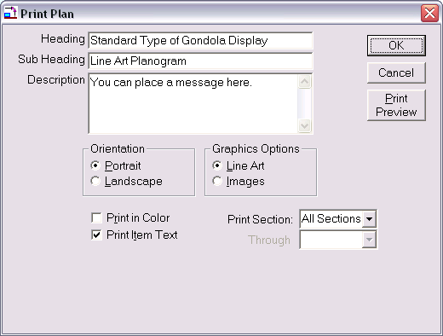
Figure 34 Print Planogram

Heading – Enter an optional heading for the planogram that will print centered at the top of the page margin in large type. This heading will become the default heading for all reports printed for this planogram, eliminating the need to re-enter it on other reports.
Sub-Heading – By default, the name of the report will appear in the sub-heading field but can be changed by the user. The sub-heading will print in slightly smaller type, centered below the heading.
Description – You may enter an optional description that will print at the bottom of the page in the footer. The report footer also contain the current date, the name of the report, the name of the planogram file, and the version of Shelf Logic® used to create the planogram.
Print in Color - Deselect this option if you are using a black and white printer.
Print Text – By selecting this option, items will print on the planogram with Item Number, Item Name, and Key Number. Deselecting this option will print items with a Key Number only. The option you select will depend upon the individual planogram. Small items print better without text.
Graphic Options – Selecting the Line Art option will print the items as boxes and custom shapes (where applicable). Selecting the Images option will print the items as photographic images, provided that an image file was entered into the items database.
Printing the Planogram by Section
In the Print Planogram dialogue box, select all sections to print the entire planogram on a single sheet of paper. Select a starting and ending section to print only selected sections of the planogram a single sheet of paper. To print a single section per page, choose that section as the starting and ending section.
After selecting the appropriate options, click the OK Button to print, or the Cancel Button to cancel printing and return to the main Shelf Logic® screen.

Section Headers and Footers
Menu: Reports/Headers & Footers
You have the additional option of creating a separate header or footer for each section of shelves on your planogram. Upon executing the above command, the Shelf Section Header and Footer box will open as shown below:
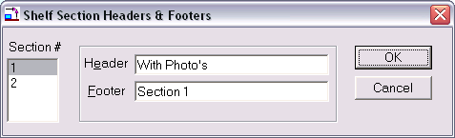
Figure 35 Section Headers & Footers
This list box will display the section numbers as defined in the Display Setup. Click the appropriate section number and enter a header and/or footer. As you click on each section number on the left, the headers and footers will clear so you can enter new ones for each section. Click the OK Button to accept, or the Cancel Button to cancel. Shelf Section Headers and Footers will appear on the printed planogram only.

Print Peg Holes
You can control whether or not background peg holes print on your final planogram by turning them on or off from the View Menu. If there is a checkmark in front of the Show Peg holes option, the peg holes will be visible on screen and will print on the planogram. Deselecting Show Peg holes will turn them off for both the screen and printed planogram.

Printing the Planogram as a Graphic Image
Menu: File/Save Plan as Image

After executing the above command, the following dialogue box will open. Heading, Sub Heading and Description are optional. Select from high-resolution image or low-resolution image, depending upon your needs. A high-resolution image will create a superior printout but creates a very large image file. A low-resolution file is more suitable for emailing and web pages, where the image will only be viewed on screen.
After clicking OK, a standard Save File dialogue box will open. Graphic files can be saved in several formats including .bmp, .jpg, .esp, and .tif.
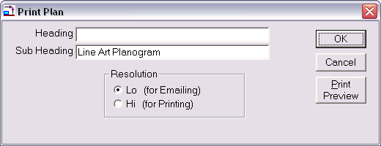
Figure 36 Create Image File

Printing the Planogram to a PRN File
This procedure will save the planogram to a file that can be sent to an outside print service. The file must be created using the same printer driver (printer software) that will be used to make the final printouts. Once you have determined the correct printer driver and have installed it on your computer, follow the instructions below to create the file.
Note: If the planogram will be printed on a USB printer, check with the manufacturer's technical support if a driver is available that supports DOS printing. If not, the following instructions will not work.
To create the print file:
- Select the Windows Start Menu/Settings/Printers.
- From the Printers Folder, right-click on the appropriate printer.
- Select Properties, and click on the Details Tab.
- In the "Print to the following port" box, click the down-arrow and select FILE. Click OK. The printer icon should now show a red arrow pointing to a disk.
- Open Shelf Logic® Pro and the plan you wish to print to a file.
- Select File Menu/Print Setup. Select the same printer as step 2. Click OK.
- Select File Menu/Print Planogram. Select applicable options and click OK.
- When prompted to do so, enter a path and file name including a file extension of .prn.

If you selected your usual printer in step 2, be sure to change the port setting back to LPT1. Follow steps 2 through 4, selecting LPT1 in the "Print to the following port" box.

To print the file:
- From the Windows Start Menu, select Programs/MS-DOS prompt.
- At the C:\Windows prompt enter the following exactly as it appears below:
CD\SL ProAd <enter key>
- If you saved your print file to another location replace SL ProAd with the name of the folder you saved to.
- At the C:\SL ProAd prompt, enter the following exactly as it appears below:

Copy filename LPT1 <enter key>
Substitute the name of your print file for ‘filename’ above.

- Type Exit at the DOS prompt to return to Windows.

Printing the Planogram to an Adobe Acrobat PDF File
The planogram and reports can be printed to a PDF file provided you have the full version of Adobe Acrobat software installed and not just the free reader software.

- Select File Menu/Printer Setup.
- Select Acrobat PDF Writer or Acrobat Distiller – click OK.
- Select File Menu/Print Plan and print as usual.

Note: PDF Writer will create a PDF file using standard default settings. Distiller allows you select advanced features and settings. Consult the Adobe Acrobat documentation for details.

Printing of Standard Reports is covered in Section 12. Printing Sales Reports and Planograms are covered in Section 13.

Section 11 – Reports

Generating and Printing Reports
Shelf Logic® Pro has several useful reports that can be automatically generated from inside the program. In addition, plan files can be exported into Excel to create custom reports.
All standard reports are accessible from the Report Menu. Upon selecting a report from the menu, the Report dialogue box will open as shown below:

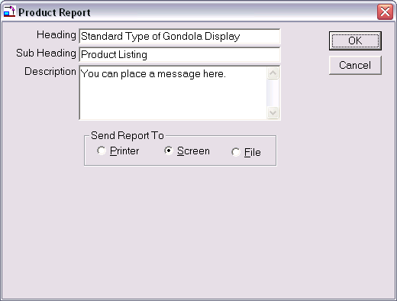
Figure 37 Report Dialogue Box
Reports displayed to screen now open in a separate window so that the plan and report can be viewed at the same time. The report can be printed or exported to a file directly from this window. The <Page Up> and <Page Down> keys are used to scroll from one page to another.
Heading – Enter an optional heading for the report. The heading will appear in large type, centered at the top of the page. This heading will become the default heading for all reports generated from this planogram.
Sub Heading – Enter an optional sub heading for the report. The sub heading will appear in slightly smaller type, centered below the heading.
Description – Enter an optional report description. The description will appear at the bottom of the report.
Send Report To –The report can be viewed on screen, sent to a printer, or printed to a file.
- When printing to the screen, the report will open in a separate window. Use the <Page Up> and <Page Down> keys to scroll through multiple pages
- When selecting the print to file option, enter a path and file name when prompted to do so. The report can be generated to a text or html file, which can be opened and customized in any word processing, spreadsheet, text or web editor application.

Standard Reports

Display Schematic Listing
This report lists all of the data needed for constructing the shelving.

Product Listing
This report lists all of the items on the planogram with details such as Item Number, Item Name, side number, side dimensions, number in stack, and hook size. This report is used for constructing the display.

Space Analysis Report
This report details how much space is taken up by each item. The report is sorted in order of items with the greatest number of facings. The amount of linear feet, square feet and cubic feet of shelf space for each item is listed, along with the percentage of total shelf space taken up by each item.

Financial Report
This report is sorted by item category and lists Item Name, the quantity on the planogram, markup percentages and profits, percentage of total space used by this item and percentage of profit. This report must be printed in landscape mode.

Item File Detail
This report prints out the items database and all details.

Item File Summary
This report prints out the items database with a summary of the item details.

Creating Custom Reports

Export the Plan File to Excel
Menu: File/Export Plan
The Shelf Logic® Pro planogram file can be exported into an Excel spreadsheet, or other application, for the creation of custom reports.
Upon executing the above command, the Windows File Save dialogue box will open. Select the default location or a new location and enter a file name. The .CSV extension will be added automatically.
When you open the .CSV file in Excel you can rearrange and format the data, add formulas, etc. Save the finished report file as an .XLS file to preserve formatting.

Custom Report Macros
Custom Excel Report Macros can be written upon request on a fee for service basis. If you have a custom report that you frequently create, an Excel macro can create the report for you in a few keystrokes. Contact Logical Planning Systems for details.

Phone (631) 289-0055
info@logicalplanning.com

Section 12 – Exporting & Importing

Exporting and Importing Files

This section requires some knowledge of Excel. Contact your System Administrator for assistance if necessary. The export and import commands are used to transfer data between Shelf Logic® Pro and other applications for the following:
Creating Custom Reports - Create the planogram in Shelf Logic® Pro. Export the planogram into Excel or Word according to the directions in this section. The data can then be moved, formatted, or edited. Formulas can also be added.

Creating a New Items Database - First export the Item.dat file from Shelf Logic® Pro to Excel. This will create the Excel spreadsheet with the correct layout. Enter your items according to the instructions in this section, and finally, import the database back into Shelf Logic® Pro.

Editing the Items Database - Export the Shelf Logic® Pro Items Database into Excel for major revisions or routine maintenance.

Importing a Database from Another Program - If you are using a database that was created for another application, it must be imported into Excel and modified for use with Shelf Logic® Pro. In order to prepare your database for import into Excel your database should have a supported export file format such as ASC, DBF or CSV. Please check Excel help for a list of supported file formats. Our recommendation is to use the ASC format as database programs almost universally support it.

Why Microsoft Excel – Excel supports many file formats and is the most popular spreadsheet program. You can also use Excel as an intermediary if you wish to do data entry in a different program such as Microsoft Access. Just import the Excel spreadsheet directly into Access, add or edit records and then export the file back to Excel or directly to ASC (.csv, .txt).

☑
***Be sure to backup all .mdb files before any import or export procedure.

Exporting and Importing a Database

Exporting the Item File from Shelf Logic® to Excel
Menu: File/Export Item File
This is the first step in creating or editing a database in Excel. This procedure will create the Shelf Logic® Pro database structure in the form of an Excel spreadsheet. A new database can then be entered, or an existing one can be edited.

The Excel spreadsheet is essentially a database laid out in the form of columns and rows. Database fields will appear as columns and items are entered in rows. The first row will contain the field names, and items begin on row 2.

Upon executing the above menu command, the active database file will be exported into a comma delimited .CSV file. The standard Windows Save File dialogue box will open. Accept the default location for the export file (c:\ShelfLogic_PE\datafile) and enter a file name. The extension of .CSV will be added automatically.

Creating the Items Database in Excel
Open Excel and the .CSV file created in the previous step. You can begin entering items according to the following instructions. If you are working with a database from another application you can copy and paste one column at a time into the appropriate Shelf Logic® column and modify the data as needed.
Some fields are required and/or require data to be entered in a specific format, such as a date or number. The number of characters in each column should not exceed the maximum field size or they will be lost when imported back to Shelf Logic®. The following chart lists the requirements for each field.
When exporting the Item file to Excel, you will notice as asterisk in front of each UPC code. This is to preserve text formatting and ensure that leading zeros will not be lost in Excel. We suggest entering new codes the same way. The asterisk is removed when importing back into Shelf Logic®.

Note: The UPC Code is the key database field and must contain a unique number for each item.
☑
If you have edited the database field labels, your column headers may differ from the following chart but the column position will still be the same.

Database Fields Chart
Column Name  & Letter | Required  Entry | Max Characters | Required Format (Data Type)
A - UPC Code | Required | (25) | Must be a unique number for each item.
B - Item No. |  | (25) | User defined, alphanumeric.
C - SKU Code |  | (25) | User defined, alphanumeric.
D - Vendor No. |  | (25) | User defined, alphanumeric.
E - Ven Name |  | (50) | User defined, alphanumeric.
F - Item Name |  | (50) | User defined, alphanumeric.
G - Item Type | Required | (1) | S=Shelf Item P=Peg Item
H - Category |  | (50) | User defined, alphanumeric.
I - Desc |  | (50) | User defined, alphanumeric.
J - Width | Required | (8) | Inches in whole numbers or decimals.
K - Height | Required | (8) | Inches in whole numbers or decimals.
L - Depth | Required | (8) | Inches in whole numbers or decimals.
M - Weight |  | (8) | In ounces.
N - Ctn Pack |  | (8) | Whole number.
O - Peghole Left | Required for peg items | (8) | Inches in whole numbers or decimals.
P - Peghole Top | Required for peg items | (8) | Inches in whole numbers or decimals.
Q - Sugg Retail |  | (7) | In dollars.
R - Cost |  | (7) | In dollars.
S - Last Chg |  | (8) | Current date will automatically be inserted. No entry required.
T - Outline Color |  | (2) | Enter a number from color chart.
U - Fill Color |  | (2) | Enter a number from color chart.
V - Pattern |  | (2) | Enter a number from color chart.
W - Image Name |  | (100) | Path and name of image file. **If the default image location is set in preferences and all images are located in that folder it is not necessary to enter a path.
X – Shape Name |  | (100) | Path and name of shape file.
Y – Nest Amount |  | (8) | Inches in whole numbers or decimals.

Color Chart
Use the following chart to enter item colors and patterns.
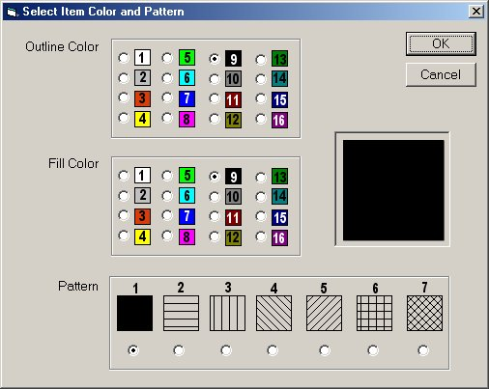
Figure 38 Color Chart

Saving the Export File
When the Excel file is completed Select File Menu/Save in Excel. You will receive several prompts from Excel trying to save the file in the native Excel format (XLS). The exact wording of the prompts varies depending upon the version of Excel, but do not save the file in XLS format. You must save it as a .CSV file.
Before closing the file, take note of how many items are in your database to compare after import. Subtract one for the header.

Importing the .CSV File into Shelf Logic®
Menu: File/Import
Note: If you are importing your .CSV file into a database other than the default database, you must first create that database or activate that database file.
☑

The following procedure will import your .CSV file into the Shelf Logic® item.mdb file.
- Make sure you have backed up your current database files.
- Open Shelf Logic® Pro.
- Click the Item Maintenance Button on the Button Bar to check that the correct database is currently active.
- From the File menu, select the Import command. The Open Import File box will open.
- Select your .csv file and click OK.

Upon completion of the above steps, the following dialogue box will open:
Clear the c:\ShelfLogic_PE\datafile\ITEM.MDB data file before importing?
If you select YES, any items already existing in the Item file will be erased.
If you select NO, your import file will be added to existing items in the item file.
Select Cancel to abort the procedure without importing.
Once the import is complete, compare the number of items imported to the number of items in the original .CSV file.
When this procedure is complete, compare the number of records indexed with the number of items in your .CSV file.

Database Import Checklist
- Did you backup existing database files?
- Did you first export the Item.mdb file to Excel?
- Did you enter data in all required fields and in the required format, as noted in the Fields Chart?
- Did you save the file as a .CSV file?
- Did you note the total number of items less the header row?
- Did you activate the correct database before importing?

Exporting Plans

Exporting the plan file to Excel
Menu: File/Export Plan
The Shelf Logic® Pro planogram can be exported into an Excel spreadsheet, or other application, for the creation of custom reports.
Upon executing the above command, the Windows File Save dialogue box will open. Select the default location or a new location and enter a file name. The .CSV extension will be added automatically.
When you open the .CSV file in Excel you can rearrange and format the data, add formulas, etc. Save the finished report file as an .XLS file to preserve formatting.

